CICS - HANDBOOK

TABLE OF CONTENTS

Session 01: What is CICS? ........................................................................................8
Features of CICS..........................................................................................................8
CICS Environment………….........................................................................................9

Session 02:CICS Functions......................................................................................10
DATA handling Functions-Interface between CICS and data....................................10
Application Programming Services-Interface between CICS and
Application Programs………………………………………………………………………10
System Services -Interface between CICS and Operating System...........................10
CICS Security.............................................................................................................11

Session 03: How Online Programs and how online differs from batch...............12

Session 04: Concepts of Task, Multitasking and Multithreading, Conversation and Pseudo Conversation and how CICS implements these...............................13
Task...........................................................................................................................13
Starting a Task...........................................................................................................13
Multitasking................................................................................................................13
Multithreaing……………………………………………………………………………….13
Modes of Application Programming...........................................................................15
Conversational...........................................................................................................15
Pseudo Conversation ................................................................................................15

Sessions 05: Concept of reentrancy and quasi reentrancy..................................19
Non-reentrancy...........................................................................................................19
Reentrancy.................................................................................................................19
Quasi-reentrancy........................................................................................................19

Session 06: CICS COMPONENTS............................................................................20
CICS Tables...............................................................................................................20
Program-control table (PCT)......................................................................................20
Processing program table (PPT)................................................................................20
Important Control Tables ...........................................................................................21
CONTROL BLOCKS ................................................................................................22
EXEC Interface Block (EIB)........................................................................................22

Session 07: Structure of a CICS Program, CICS Compile Procedure..................23
Basic Steps in CICS Application Program Development..........................................23
Structure of CICS Application Program.....................................................................23
Steps In Application Development ...........................................................................24
Compilation of COBOL-CICS Program.....................................................................24
Data between Transactions – COMMAREA.............................................................25
Sample CICS Program..............................................................................................26
CICS Statements after Translation ...........................................................................27
Original Source Code................................................................................................27
Translated Source.....................................................................................................27
The CICS Translator.................................................................................................27

Sessions 08: CICS Transaction Initiation Process................................................28

Sessions 09: Concept of Maps................................................................................29
IBM Terminals...........................................................................................................29
Basic Mapping Support.............................................................................................29
Functions of BMS....................................................................................................30
MAP & MAPSET.......................................................................................................30

Sessions 10: Physical Map.......................................................................................31

Sessions 11: Symbolic Map……………………………………………………………..32
Sessions 12: Processing BMS MAPS......................................................................33
Coding an Assembler macro.....................................................................................34
Coding a BMS macro................................................................................................34

Sessions 13: Defining Mapsets................................................................................35
DFHMSD.................................................................................................................35

Sessions 14: Defining Maps.....................................................................................36
DFHMDI....................................................................................................................36

Sessions 15: Defining Fields....................................................................................37
DFHMDF...................................................................................................................37

Sessions 16: Modified Data Tag (MDT)...................................................................38

Sessions 17: BMS Input/output Operations...........................................................39
Three basic functions of CICS commands for BMS..................................................39
Map Sending Function..............................................................................................39
Map receiving Function.............................................................................................39
Text Handling Function ............................................................................................39
SEND........................................................................................................................39

Sessions 18: Screen Definition Facility (SDF)........................................................43
Advantages of using SDF............................................................................................43

Sessions 19: Exception Handling............................................................................44
Exceptional Condition Abend codes..........................................................................44
RESP OPTION..........................................................................................................45
HANDLE CONDITION COMMAND...........................................................................47
IGNORE CONDITION COMMAND ..........................................................................48
HANDLE AID COMMAND.........................................................................................49
HANDLE ABEND......................................................................................................50

Sessions 20: PUSH & POP.......................................................................................53
Sessions 21: CICS – Testing and Debugging.........................................................54
Master Terminal Transaction (CEMT).......................................................................54
CECI (Command Level Interpreter)...........................................................................54
Execution Diagnostic Facility (EDF)..........................................................................55
EDF - Interrupt Points ...............................................................................................55
Information Available at Interrupt Points...................................................................55
EDF - Interacting with program.................................................................................55
EDF - Other options..................................................................................................55
EDF Invocation..........................................................................................................56
Temporary Storage browse (CEBR) ........................................................................62

Sessions 22: File handling.......................................................................................63
File Control Service...................................................................................................63
File Access Methods.................................................................................................63
Entry Sequenced Data Set (ESDS)...........................................................................64
Key Sequenced Data Set (KSDS) ............................................................................64
Relative Record Data Set (RRDS)............................................................................64
Record identification (RIDFLD)………………………………………………………….64
VSAM File – Random Access……………………………………………………………65
VSAM File – Sequential Access................................................................................65
VSAM - READ from File............................................................................................65
VSAM – Write to File.................................................................................................67
VSAM - File Update ..................................................................................................67
VSAM – File Unlock..................................................................................................68
VSAM - Delete from File............................................................................................68
VSAM - BROWSE Operation....................................................................................69
VSAM - BROWSE Commands..................................................................................69

Sessions 23: File Handling - Exceptional Conditions............................................71

Sessions 24: VSAM Alternate Index……………………………………………………72
Concept of Alternate Index........................................................................................72
Path...........................................................................................................................72
Creating AIX..............................................................................................................73

Sessions 25: CICS - Database Access....................................................................75
DB2 Database Access from CICS.............................................................................75
DB2 Compilation Process.........................................................................................75
DL/I DB ACCESS......................................................................................................77

Sessions 26: CICS Queuing Functions………………………………………………..78
CICS TDQ.................................................................................................................78
Types of TDQs..........................................................................................................78
INTRAPARTITION TDQ............................................................................................78
Typical Applications of Intrapartition TDQs…………………………………………….79
EXTRAPARTITION TDQ...........................................................................................79
Typical Applications of Extrapartition TDQs .............................................................80
TDQ- CICS Commands.............................................................................................80
Destination Control Table (DCT)...............................................................................28
Automatic Task Initiation (ATI)..................................................................................82
Application of TDQ....................................................................................................83
Message Switching...................................................................................................83
Report Print...............................................................................................................83

Sessions 27: TSQ………………………………………………………………………….84
Features of Temporary Storage Queue......................................................................84
TS Queues - CICS Commands...................................................................................84
TSQs - Exceptional Conditions...................................................................................85
Temporary Storage Queue - Syntax...........................................................................86

Sessions 28: Difference between TDQ and TSQ…………………………………..…87

Sessions 29: Program Control Commands…………………………………………...88
LINK.........................................................................................................................89
Passing Data using LINK..........................................................................................90
LINK Command.........................................................................................................91
XCTL.........................................................................................................................91
Passing Data using XCTL.........................................................................................92
XCTL Command........................................................................................................92
Difference between XCTL and LINK.........................................................................93
CALL.........................................................................................................................94
Static CALL...............................................................................................................94
Dynamic CALL..........................................................................................................94
Passing Data in CALL...............................................................................................95
Difference between CALL and XCTL/LINK...............................................................95
RETURN...................................................................................................................96
LOAD........................................................................................................................97
LOAD command – Syntax.........................................................................................97
LOAD Command Exceptions....................................................................................97
RELEASE..................................................................................................................97
RELEASE Command – Syntax.................................................................................98

Sessions 30: Interval Control……………………………………………………………99
ASKTIME....................................................................................................................99
FORMATTIME..........................................................................................................100
FORMATTIME – Example…………………………………………………….…………101
DELAY…………………………………........................................................................101
DELAY Command –Syntax………………………………………………………………102
START......................................................................................................................102
Scheduled Transaction Initiation ( STI )………………………………………………..102
RETRIEVE................................................................................................................103
Retrieve Command –Syntax……………………………………………………………104
START & RETRIEVE: Example…………………………………………………………104
CANCEL....................................................................................................................104

Sessions 31: Task Control Commands………………………………………………106
SUSPEND Command.............................................................................................106
ENQ and DEQ Commands.....................................................................................106
ENQ Command.......................................................................................................106
DEQ Command.......................................................................................................107
ENQ & DEQ for TSQ Access: Example .................................................................107

Sessions 32: Storage Control………………………………………………………….108
GETMAIN..................................................................................................................108
FREEMAIN .............................................................................................................108

THIS PAGE HAS BEEN LEFT BLANK INTENTIONALLY

Session 01: What is CICS?

CICS (Customer Information Control System) is an IBM database/data communication (DB/DC) system. CICS makes it easy to send, receive, and process data through interaction with a terminal that consists of a display unit or cathode-ray tube (CRT) and a keyboard. CICS runs on IBM and IBM-compatible mainframe and microcomputer systems and provides an interface between application programs and the computer’s operating system. It functions like an online operating system. CICS application programmers use command-level COBOL to code easy-to-use instructions into their programs. These commands facilitate accessing and updating online database files, data entry, and display of data and other information on the display terminal. Users of CICS can transmit data from their terminals to the system where the data is processed and then sent back to the user.

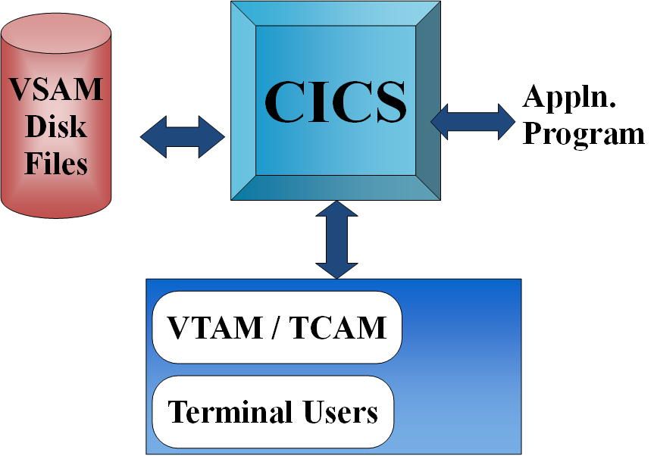

1.1 Features of CICS

- CICS is a single task to MVS although it behaves like an operating system within an operating system, whose job is to provide an environment for the execution of on-line jobs including interfaces to files and databases.
- CICS address space is given a favored status within the MVS system.
- CICS has a multi-region operation feature, i.e., multiple CICS address spaces can communicate with each other
- CICS is easy to develop on-line applications and its Coding is similar to high level languages.
- CICS has Common interface to database and Data sets.
- CICS has Better response time.
- CICS is easy to customize.
- CICS does not need to code data for the purpose of displaying data onto the screen.
- CICS gives easy forms development using BMS facility.
- CICS is Device independence.
- CICS has Data independence.
- CICS enables sharing of code between applications.
1.2 CICS Environment

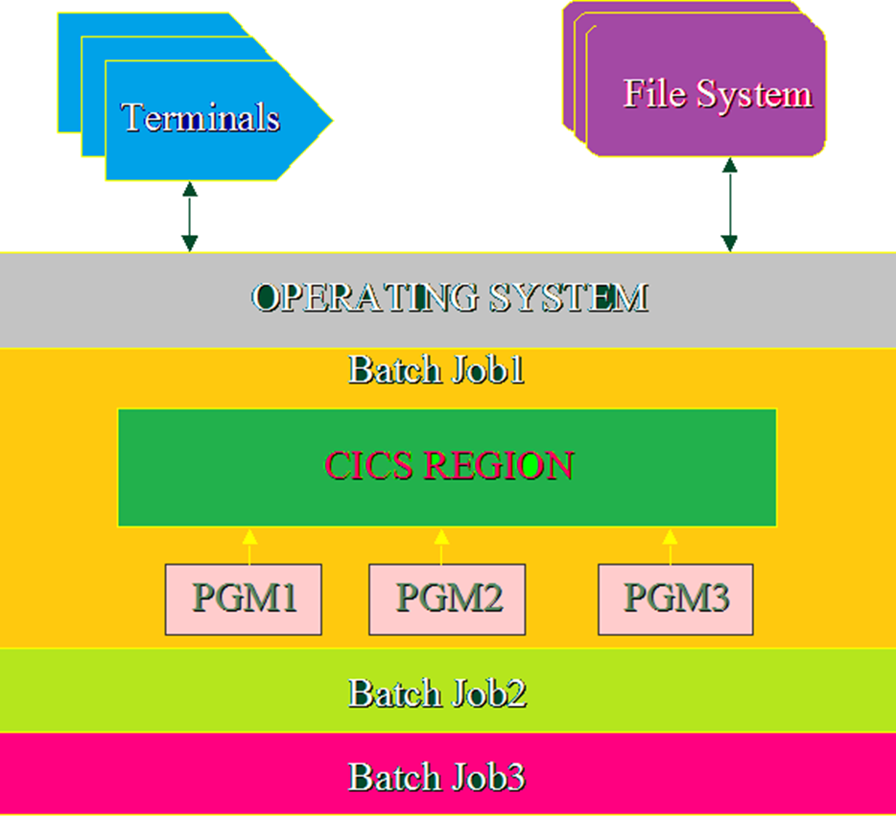

Session 02: CICS Functions

2.1 DATA handling Functions-Interface between CICS and data
- Provides interface with data access methods like VSAM (virtual storage access method).
- Provides interface with database access methods, such as DB2.

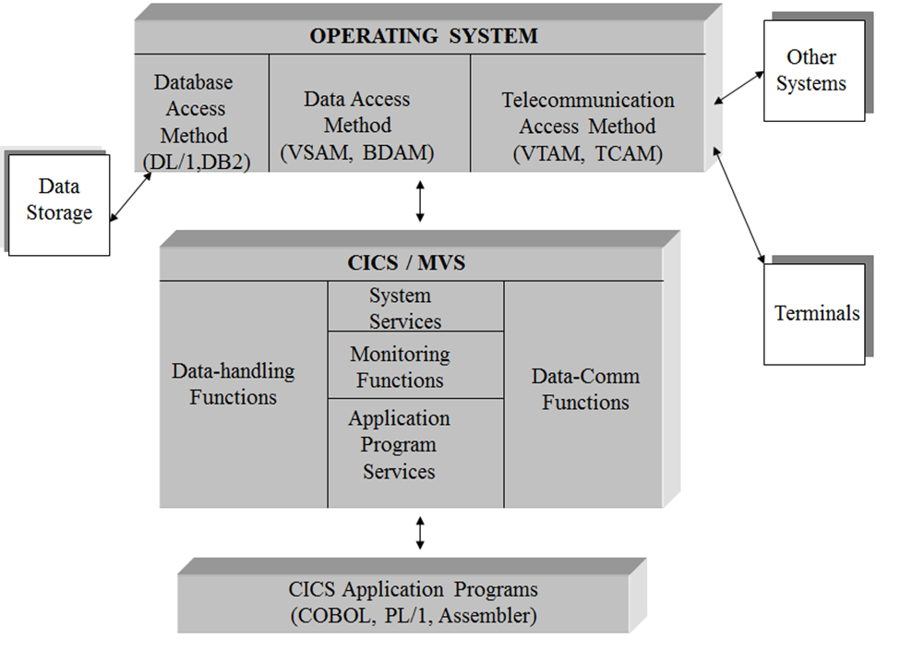
2.2 Application Programming Services-Interface between CICS and Application Programs
- Provides interface with COBOL, PL/I, Assembler programs
- Provides CICS command level translation.
- Provides services like CICS Execution Diagnostic Facility (CEDF),CICS enhanced command interpreter (CECI)

2.3 System Services -Interface between CICS and Operating System
- Provides Program Control, such as load and release of application programs.
- Provides Storage Control, such as acquiring and releasing of storage.
- Provides Task Control, such as task scheduling.
2.4 CICS Security
- SIGN ON -
The primary function of CICS SIGN ON is to associate CICS user identifier with CICS system in terms of security, Priority and other functions.
    - CESN or CSSN is CICS supplied transaction which prompts SIGN ON screen as shown.
    - Complete SIGN ON by giving correct USERID & PASSWORD
    - Unless SIGN ON process is complete NO CICS transaction can be invoked.
- SIGN OFF -
The primary function of SIGN OFF is to disassociate CICS user identifier from CICS Region.
For SIGN OFF use CICS supplied transaction CSSF.

Session 03: How Online Programs and how online differs from batch

Batch System v/s Online System
Input | Data from card, tape and disk. In Batch, Sequential,  Scheduled E.g. Keypunch, Data Coding | Data from terminal.  Random, concurrent. Can be entered as data arrive.
Update  Of file | Reserved during a job. Other jobs have to wait. | Concurrent. Instant.
File I/O | I/O must be in sequence. | I/O can be concurrent
Output | Printed reports, O/P files. | Messages thrown to console, Updated files System log, Reports.
Start of job | Operator (or OS) initiates job | Entering Trans-ID triggers the transaction
Process mode | Single task & thread Priority in job scheduling | Multitask & Multithread Priority processing
End of job | Each job | Each transaction
Turn-around | Usually much longer | Almost Instantaneous
Resources | Less Usage | More Usage
Application | Monthly Sales Report | Airline Reservation

Sessions 04: Concepts of Task, Multitasking and Multithreading, Conversation and Pseudo Conversation and how CICS implements these

4.1 Task
A task is created for each executed transaction identifier, TRANSID, recognized by CICS (found in the PCT). A task can include one or several programs. A task continues until a program returns control to CICS or issues a RETURN command in a pseudo-conversational program. Only one task can be executing at a given time, but the user may perceive that many tasks are running.

4.1.1 Starting a Task
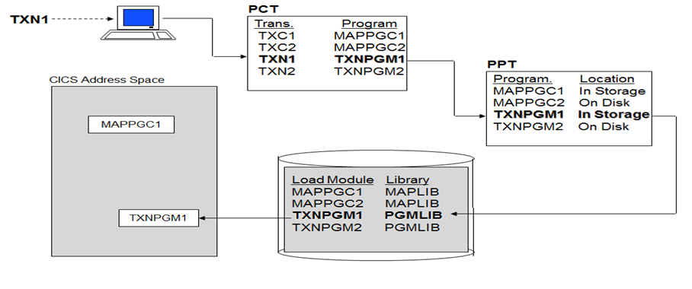
4.2 Multitasking

Multitasking means that the operating system (OS) allows more than one task to be executed concurrently, regardless of whether the tasks use the same program or different programs. Therefore, this is not a unique concept to CICS. But CICS manages multitasking of CICS tasks within its own region. That is, CICS provides a multitasking environment where more than one CICS task runs concurrently.

4.3 Multithreading
Multithreading is the system environment where the tasks are sharing the same program under the multitasking environment. Multithreading is a subset of multitasking, since it concerns tasks which use the same program.

Under the multithreading environment, a program is shared by several tasks concurrently. For each task, the program (i.e., instructions and data area) must work as if it were executing instructions exclusively for each task. Therefore, it requires special considerations such as reentrancy or serial reusability.
Contrary to the multithreading environment, under the single threading environment, a program is used by only one job (or task) at a time. A typical example is a batch job.
Figure 1.1 illustrates how multitasking and multithreading might utilize main storage. Four users at different terminals have entered the TRANSID DSPL and three users have entered the TRANSID RECV, starting seven different tasks. The initial task for each TRANSID resulted in the corresponding program in PCT obtaining the associated program’s load library address for each program from the PPT. The load module was then loaded into main storage and its main storage address moved into the PPT.
Each task for both programs obtained a copy of its own unique working storage in main storage as shown. As each task completes, its working storage can be released from main storage. When all tasks accessing a program are complete, program can be released from main storage (if not defined as resident program) if main storage is required for another task.
PCT | PPT Table Entries
Transid Program | Program Main Storage Address Load Library Address
DSPL DISPLAYP  RECV RECEIVEP | DISPLAYP 2000 10500  RECEIVEP 3000 25600

TASK 00311 Working Storage
Other Tasks
TASK 00328 Working Storage

DISPLAYP Load Module
TASK 00322 Working Storage

TASK 00317 Working Storage

Other Programs …..
RECEIVEP Load Module
TASK 00311 Working Storage

TASK 00311 Working Storage

TASK 00311 Working Storage

Figure 1: CICS Multitasking and Multithreading

4.4 Modes of Application Programming
- Conversational
- Pseudo-Conversational

4.4.1 Conversational
- System sends a message to the screen
- Waits for the user response.
- This takes considerable amount of time in terms of system time. This time is called THINK TIME of the user. (Disadvantage)
- Receives the response
- Process the received data.
Conversational programming is a coding technique that results in a program being loaded into and remains in main storage until user finishes working with the program. The program is not released from main storage when not active, as in pseudo conversational programming. For instance, a conversational program displays a map and remains in main storage while waiting for a user’s response.
Practical applications of conversational programming are very limited.

4.4.2 Pseudo Conversation
- System sends a message
- Terminate the transaction specifying the next transaction to be started
- Allocate resources to other transaction
- Poll the terminal input at regular interval
- Receives the data and start the next transaction specified previously
CICS allows many users to log on and use CICS concurrently. Computer main-storage size is finite. If numerous users are running transactions demanding considerable main storage, a short-on-storage condition could occur, causing delays.
Pseudo-conversational programming is a coding technique that results in a program being loaded into main storage when required and released when it is no longer active. For instance, when a map is displayed and the program is waiting for a user’s response, the program can be released from main storage and reloaded when needed.
CICS loads and releases application programs from main storage automatically. High-use programs are often defined as main-storage-resident, and the system keeps them in main storage. Tables and maps, which are considered programs by CICS, are usually controlled by a program.
Generally, when using the Pseudo-conversational technique of processing, pressing an AID key causes a program to be loaded if it is not already in main storage. When a program is finished with a logical segment of processing, it normally sends a map, saves required data, and returns control to CICS.

Advantages of Pseudo-conversation

- Resources are best utilized (The Resources are released as soon as the program is suspended temporarily)
- Looks as if it is in conversational mode
- Better response time

Pseudo - conversational Techniques

- The most important thing is passing of data between pseudo-conversational tasks.
- We can pass data via a COMMAREA
- WS variables get destroyed once the task is over but the DFHCOMMAREA is retained (Max size 32K)

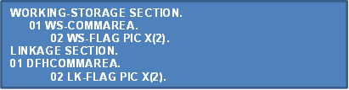

Return Statements
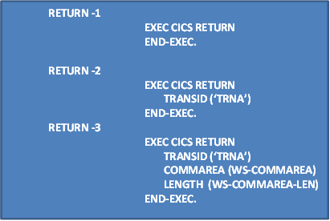

- Even though we do a passing of a common area and return with a TRANSID and COMMAREA option we have to check for the first enter into the program.
- We can solve this by using EIBCALEN which stores the length of the COMMAREA.
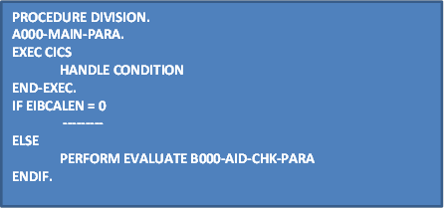

Now when the program has entered for the next time. How was it initiated?
- By pressing some AID keys.
- AID keys have different Functions- In your screen so in-order to carry out that function you have to go to the paragraph in your COBOL program doing that task.
- To keep track of your AID keys the following things need to be done:
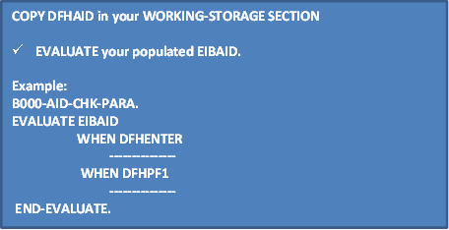

Now your single function can also contain sub functions. How will you keep track of that?

- By using FLAGS logically. The flag is passed to the WS-COMMAREA and retain it by accessing DFHCOMMAREA

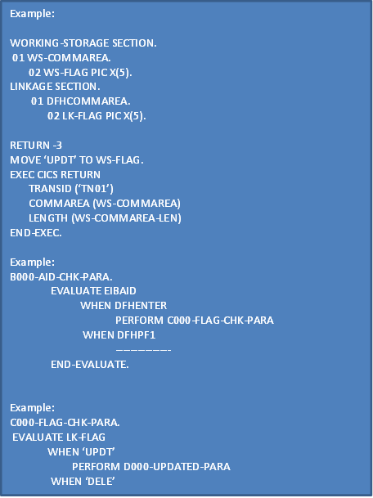
Sessions 05: Concept of reentrancy and quasi reentrancy

5.1. Non-reentrancy
- A non-reentrant program is a program which modifies itself so that it cannot reenter to itself. Therefore, it cannot be used in the multithreading environment. Batch programs are the typical examples of non-reentrant program.

5.2 Reentrancy
- A Reentrant program is one which does not modify itself and can reenter to itself and continue processing after an interruption by the operating system (OS) which, during the interruption, executes other OS tasks including OS tasks of the same program. It is also called a “re-enterable” program or “serially reusable” program.
- Reentrant programs are used in the online system, and they make it possible for OS to establish the multithreading environment which the online system requires. Therefore “reentrant program” is a term for the OS/multithreading environment.

5.3 Quasi-reentrancy
- A Quasi-reentrant program is reentrant program under CICS environment. Quasi-reentrant program is a CICS program which does not modify itself. That way, it can reenter to itself and continue processing after an interruption by CICS which during the interruption executes other CICS tasks including CICS tasks of the same program.
- CICS ensures reentrancy by acquiring a unique storage area for each task.

Sessions 06: CICS COMPONENTS

- Control Tables
- Control Blocks
CICS core nucleus consists of Control Programs & their corresponding Control Tables

- The core portion or Nucleus of CICS consists of IBM supplied control programs and corresponding user defined CICS control tables.
- CICS control programs perform their primary task based on the entries in the corresponding user defined CICS control tables.
- Programmers can modify the control table entries depending on requirement

6.1 CICS Tables
CICS uses many tables. Only the few that are of direct interest to the application programmer are discussed. An user initiates a compiled CICS program by clearing the screen and keying a four-character TRANSID, which directs CICS to start a program at the terminal. Identifying the TRANSID and program to CICS and tying them together is necessary, and this is accomplished by means of two tables that are very important to the CICS programmer.

6.1.1 Program-control table (PCT)
The basic function of the PCT is to tie together the TRANSID with the program name. TRANSID and PROGRAM are the PCT entries.
Once an user enters a TRANSID to start a transaction, then the TRANSID is matched against the PCT to determine if it is a valid entry. A TRANSID not in the PCT causes an invalid TRANSID message to display on the terminal. A match on TRANSID uses the associated program name to search the PPT for a match on PROGRAM. The program is loaded into main storage if it is not a main-storage-resident program or already in main storage.

6.1.2 Processing program table (PPT)
The PPT contains entries such as:
- Program name, language and size
- The main-storage address of the program (if it has been loaded)
- A task use counter
- The load library address of the program to be loaded into main storage
- An indicator whether the program is main-storage-resident

A PPT entry is used to locate programs to be loaded into main storage and is required for each program, map and table the CICS system uses. When CICS is started up, the PPT is initialized with the address of the load module for all programs, maps and tables. When a program is changed and compiled or assembled after CICS has been started up, the address of the load module in the PPT must be refreshed – a normal occurrence on the test system.
The new load module address can be placed into the PPT by the following master terminal transaction entered on cleared screen:

CEMT INQ PRO (progname) NEW
Both tables contain additional entries usually maintained by the systems programming staff. Clear the screen, key in the TRANSID RECV, and press ENTER.CICS finds the TRANSID RECV and the program name RECEIVEP in the PCT. The PCT ties the transaction to the PPT entry RECEIVEP. The PPT entry is used to locate the associated program’s load module and to load it into main storage.

Control Programs | Control Tables
PCP(Program Control Program) | PPT(Processing Program Table)
SIP(System Initialization Program) | SIT(System Initialization Table)
TCP(Terminal Control Program) | TCT(Terminal Control table)
SCP(Storage Control Program) | SCP(Storage Control Table)
KCP(Task Control Program) | PCT(Program Control Table)
FCP(File Control Program) | FCT(File Control Table)
TSP(Temporary Storage Program) | TST(Temporary Storage Table)
TDP(Transient Data Program) | DCT(Destination Control Table)

6.2 Important Control Tables
- PCT: Unique Transaction-id, program name
- PPT: Program or Mapset name, Lang, Size, Load library address
- FCT: File/Dataset name, File type, LRECL

All files being used in CICS program must be declared in FCT and they are opened and closed by CICS itself (No FILE-CONTROL section, OPEN file or CLOSE file in a CICS program)

- RCT: Transaction-id, DB2 Plan name

6.3 CONTROL BLOCKS
6.3.1 EXEC Interface Block (EIB)
CICS provides system related information to each task in the form of Exec interface block. Since the information is automatically provided by CICS the application program can use it straightaway.
Some of the most commonly used EIB information are
- EIBAID: Value of last Attention identifier key pressed (1 BYTE)
- EIBCALEN: Length of DFHCOMM AREA (S9 (4) COMP).
- EIBDATE: Date when this task is initiated (S9 (4) COMP-3).
- EIBFN: Function code of the last CICS command in HEX (2 BYTES).
- EIBRCODE: Response code of the last function (6 BYTES )
- EIBTASKN: Task Number of the Current Task (S9 (7) COMP-3).
- EIBTIME: Time when the Current Task was started (S9 (7) COMP-3).
- EIBTRMID: Terminal-ID from where task initiated (1-4 characters).
- EIBTRNID: Transaction-id of Current Task (1-4 characters).

Sessions 07: Structure of a CICS Program, CICS Compile Procedure

7.1 Basic Steps in CICS Application Program Development
- Translate, compile and linkedit a CICS application program into the CICS application program library (LOADLIB).
- Define Trans-ID into PCT with associated program name
- Define program into PPT
- Register Terminal into TCT
- Register the user in SNT(Sign-On Table)
- Other CICS tables e.g. FCT, JCT, DCT must be prepared for the application programming if required
- Sign-On CICS and enter Trans-ID\
In addition to the above basic procedures, the detailed CICS system environment must be prepared properly by the system programmers or application programmers.
- The terminal must be registered in the TCT.
- The CICS user identifier must be registered in the SNT.
- Other CICS tables (viz. FCT, JCT, and DCT) must be prepared for the application program, if required.

7.2 Structure of CICS Application Program
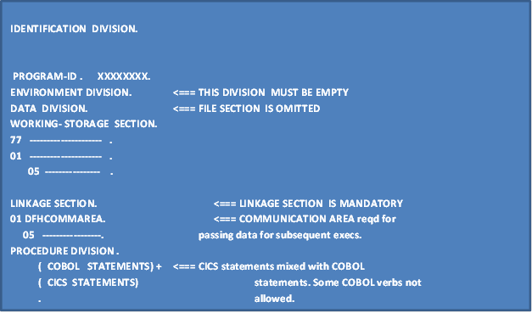

7.3 Steps In Application Development
7.3.1 Compilation of COBOL-CICS Program
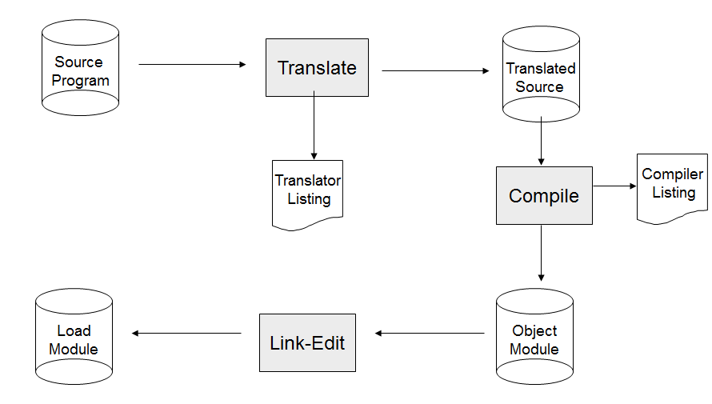
Figure 2: CICS Compile Procedure

Translator
Checks for syntax errors etc., in CICS commands & translate them into equivalent COBOL statements.

Compiler
Expands COBOL copy books, checks the source code for syntax errors etc., and compiles.

Linkage Editor
Links different object modules to create a single load module.
As translator doesn’t expand COBOL copy books, they should not contain any CICS commands.
As the module is going to be a part of CICS program, it should not contain any restricted COBOL commands.

7.4 Data between Transactions – COMMAREA
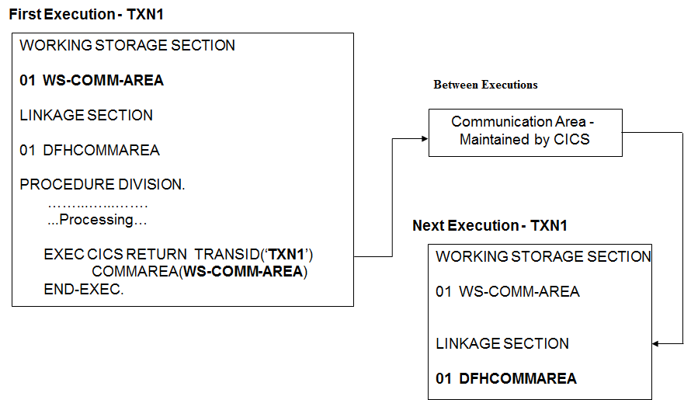
Figure 3: CICS Communication Area Data Passage
The example above depicts the same transaction being executed again. This is a very common practice and is the basis for the pseudo-conversational programming style normally employed in CICS programming.
The data between successive executions is passed through a COMMAREA, which is coded as DFHCOMMAREA in the Linkage Section. A corresponding data area must also be defined in the Working Storage section of the same program, shown as WS-COMM-AREA in the above slide. This is the source of the data that is passed on to the next execution of the transaction.
It is always a good practice to code the DFHCOMMAREA. Otherwise, the CICS translator will insert the DFHCOMMAREA in the linkage section with PIC X.
The CICS translator will also insert a copybook called DFHEIBLK before the DFHCOMMAREA. This copy book pertains to the EIB (Execution Interface Block) and it contains vital information that can be used by the application program.

7.5 Sample CICS Program
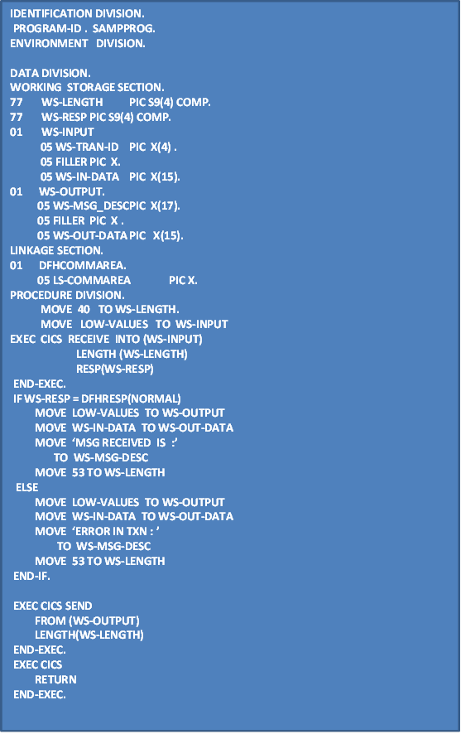
This sample program uses three basic CICS commands RECEIVE, SEND and RETURN.
This program will
- Read a message from the terminal.
- Send the message back with acknowledge message.
- Terminate the transaction.
Note the error handling part after the EXEC CICS RECEIVE command.

7.6 CICS Statements after Translation
7.6.1 Original Source Code
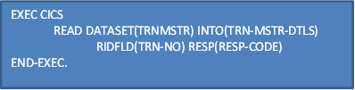
7.6.2 Translated Source
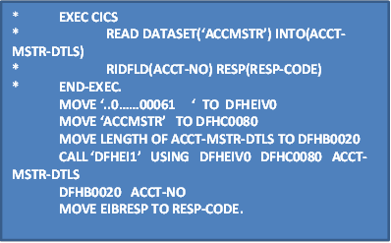
7.6.3 The CICS Translator
- Looks for the statements EXEC CICS …
- Comments out the entire EXEC CICS … END-EXEC statement
- Replaces the CICS statements with a set of MOVE statements and COBOL “CALL” statements and passes as parameters, the command options.
- Insert the Execute Interface Block copybook DFHEIBLK in the LINKAGE Section of the program.
- Add the DFHCOMMAREA in the linkage section with a size of 1 byte if it is not specified.

Sessions 08: CICS Transaction Initiation Process

CICS Nucleus
O  LOADLIB  Terminal  T  H  E  R  S | P  C  P | K  C  P | S  C  P | T  C  P
O  LOADLIB  Terminal  T  H  E  R  S | P  P  T | P  C  T

Application Program
TIOA

TCA

Figure 4: Initiation of CICS Transaction
There are five ways of initiating CICS transactions
- By a transaction identifier entered in a terminal with ENTER key. This is the most common way of initiating a CICS transaction.
- By a transaction identifier associated with a terminal for pseudo-conversation. This is a typical way of achieving a pseudo-conversation.
- By the START command, which initiates a transaction specified in the parameter.
- By the Automatic Task Initiation (ATI). The Destination Control Table (DCT) entry for an Intrapartition Transient Data Queue can have a trigger level parameter and the associated CICS transaction to be initiated if the trigger level is reached.
- By a 3270 attention identifier. For the IBM 3270 type terminals, any of the PF keys could be defined in PCT to initiate a transaction.
Note: About 3270 terminals
- It’s an Information Display System with a keyboard with AID keys & Non AID keys
  - PF Keys (PF1 to PF24,ENTER)
  - PA Keys (PA1 to PA3,CLEAR)
- the display terminal
  - 24 ROWS
  - 80 COLS
  - Individual Accessibility of screen positions.
- a printer etc.,
Sessions 09: Concept of Maps

9.1 IBM Terminals

- The CICS Terminal Control Program (TCP) provides communication services between user-written applications and terminals, using information defined in the Terminal Control Table (TCT).
- To communicate with any of these terminals, the data should be sent in their native mode. i.e., they must receive data stream in their native mode called Native Mode Data Stream (NMDS).
- NMDS is mixture of Buffer Control characters and Text data which is unique for individual terminal types based on their hardware protocol.
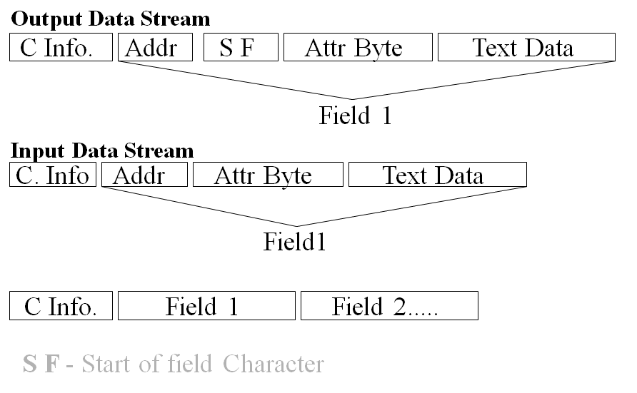
Figure 5: NMDS for an IBM 3270 terminal

Problems with NMDS are that it is...
    - Device Dependent (Hardware specific)
    - Format Dependent
    - Difficult to code
In order to free application programs from such problems CICS provides BMS which is device independent as well as format independent.
BMS Macros are used to define the screen parameters. Once defined, JCL is used to assemble it.

9.2 Basic Mapping Support
- BMS is an interface between the application program and the terminal
- BMS maps device independent data into device dependent data to provide a formatted screen
- BMS identifies the location and characteristics of data fields as well as the characteristics of the terminal with which the map will be used

9.2.1 Functions of BMS
- To remove device dependent codes and constant information from an application and to place them in maps thereby simplifying programming job.
- Keeps Code largely independent of
- Any changes in network of terminals
- Any changes in the terminal types
- Other functions include...
- Processing text
- Page building
- Multiple screens of data
- Message Routing

9.2.2 MAP & MAPSET
MAP: Representation of one formatted screen
MAPSET: Collection of one or more map(s)

Types of MAPS
- Physical Map
- Symbolic Map

Sessions 10: Physical Map

- It is a program in the form of a load module.
- It is a table equivalent of screen layout.
- It resides in the program load library.
- It is loaded when executing program requests send/receive BMS services.

Physical map contains the display format for the map, for a given terminal, available as a load library member.
- Length and location
- Attributes
- Constants
- Device characteristics

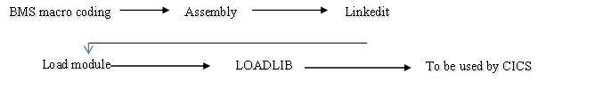
Figure 6: Compile Process of a Physical Map
Sessions 11: Symbolic Map

- It is a group structure of COBOL variable declaration for map fields.
- It resides in the COPY books library.
- It is copied into the source program by the compiler during compilation of CICS application program.

Symbolic map contains all variable data which is copied into programs working storage section, available as copy library member.

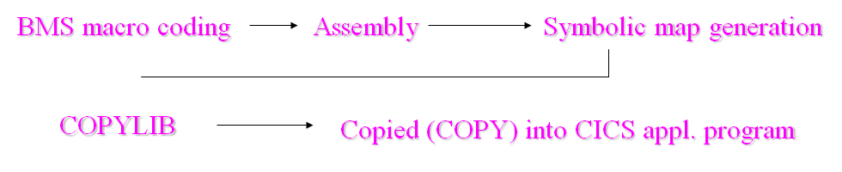
Figure 7: Compile Process of a Symbolic Map

Sessions 12: Processing BMS MAPS

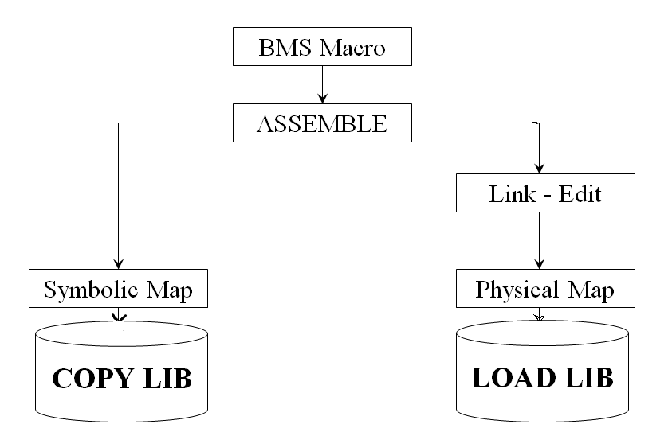

Figure 8: Compile Process of a Mapset with MAP

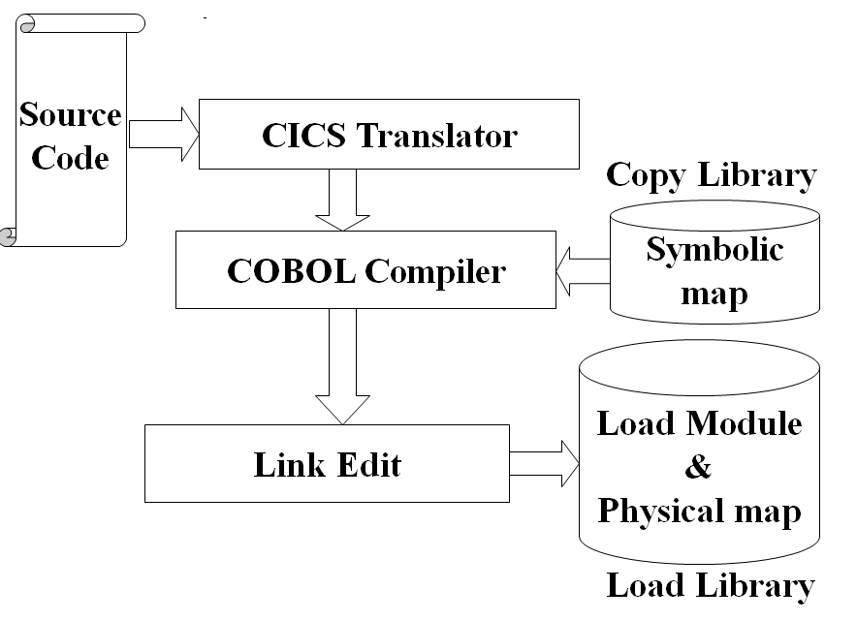

Figure 9: Compile of a CICS program with Maps
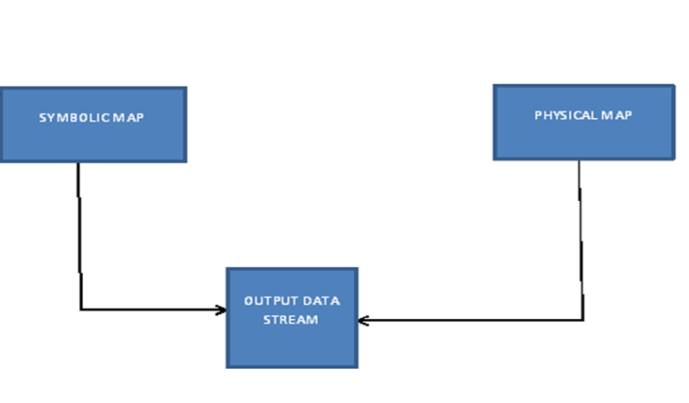
Figure 10: User Interface with CICS Map

12.1 Coding an Assembler macro
- An ‘*’ in Column 1, notifies that it is a comment line
- Name field for a mapset / map / field starts from Col. 1
- Operation field starts at Column 10
- Operands field starts at Column 16
- Any line continued to the next line, should have a non- blank character in Col. 72 and should start after Column 2 in the next line
- Operands should be separated by commas without spaces in-between them.
- END is coded in columns 9 through 11 to delimit the program.
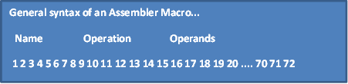

12.2 Coding a BMS macro
Macro definition for Fields, Maps and Mapsets –

  - DFHMSD
- defines a Mapset
- one per mapset / BMS file
  - DFHMDI
- defines a Map
- one per Map & one or more Maps per Mapset
  - DFHMDF
- defines a Field
- one per field & one or more Fields per Map
Sessions 13: Defining Mapsets

13.1 DFHMSD
- This Operation denotes that the definitions are for a mapset and defines the mapset property which consists of one or more maps.
- The Operands, apart from other things,
  - specify whether the program will generate physical maps or symbolic maps or both while assembling the code
  - specify whether the maps will be used as I/P, O/P or both

DFHMSD Syntax
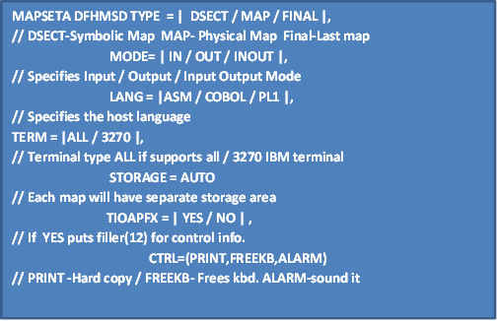

Sessions 14: Defining Maps

14.1 DFHMDI
- This Operation denotes that the definitions are for a Map and defines the Map properties which consist of one or more fields.
- The Operands, apart from other things,
  - specify the size and position of the map on the screen

DFHMDI Syntax:

- 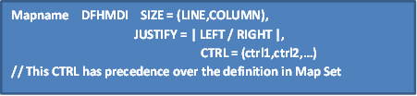
Sessions 15: Defining Fields

15.1 DFHMDF
- This Operation denotes that the definitions are for a Field within a Map.
- The Operands, apart from other things specifies
    - length and relative position of the field on the map
    - attributes of the field
    - default values for the field whether the field is part of a group variable or not.

DFHMDF Syntax:

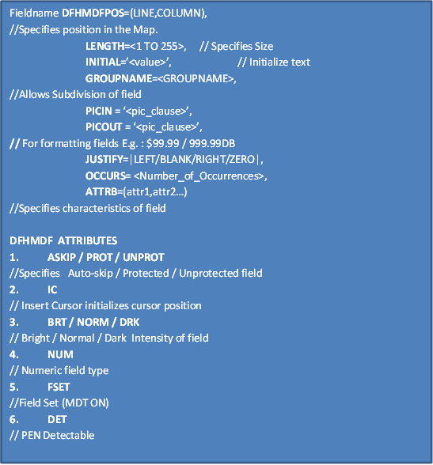
Sessions 16: Modified Data Tag (MDT)

- MDT indicates whether the data field is modified or not.
- If the MDT is ON for a field, then that data is transmitted to the program.
- If MDT is OFF, no data is transmitted for that field.
Sample BMS Coding:
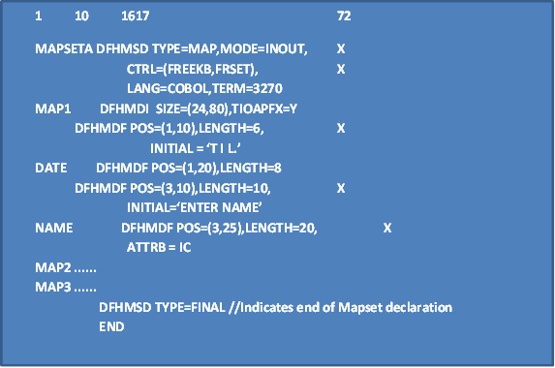
Sessions 17: BMS Input/output Operations

17.1 Three basic functions of CICS commands for BMS
17.1.1 Map Sending Function
Using the data in the symbolic map, BMS prepares the output Native Mode Data Stream (NMDS) the corresponding physical map, and sends to the terminal (or printer).

17.1.2 Map receiving Function
Using the input NMDS from the terminal, BMS prepares data in the symbolic map through the corresponding physical map.

17.1.3 Text Handling Function
BMS prepares text without using a map and sends to the terminal.

17.2 Available Basic Commands
- SEND MAP: To send a map
- RECEIVE MAP: To receive a map
- SEND CONTROL: To send a control function to the terminal.
- SEND TEXT: To send a text
- SEND PAGE: To send the accumulated text or maps as a logical message

17.2.1 SEND
MAP defines the name of the map defined in the corresponding DFHMDI macro.
MAPSET defines the name of the mapset defined in the corresponding DFHMSD macro. CURSOR makes the application program to position the cursor dynamically on any part of the screen.
ERASE erases the current screen before displaying the map to be sent.
If nothing else is specified, the FROM option is assumed, and BMS automatically finds the symbolic map area to take the data to the terminal.
The format shown is the simplest way of issuing the SEND MAP command, for which the map/mapset must be coded with STORAGE=AUTO option in the corresponding DFHMSD macro.
In addition, there are several commonly used options for the SEND MAP command.
Commonly Used Options for the basic use of the SEND MAP command:
ERASE: The current screen will be erased before the map specified appears on the screen. Without ERASE option the map specified will be overwritten onto the current screen. Therefore a double image screen might appear, which may be useful for sending error messages into the
Current screen, because the current screen will be kept as it is.

ERASEUP: Erases all unprotected fields. The protected fields or attribute fields remain as they are in the current screen. Therefore, if the error messages are sent into the protected fields and if have refreshed the screen, this option should not be used. Instead the SEND MAP command with the ERASE option should be used.
The basic format of SEND MAP command is to send message on the screen.

EXEC CICS SEND
MAP(name)
MAPSET(name)
[CURSOR]
[ERASE]
END-EXEC

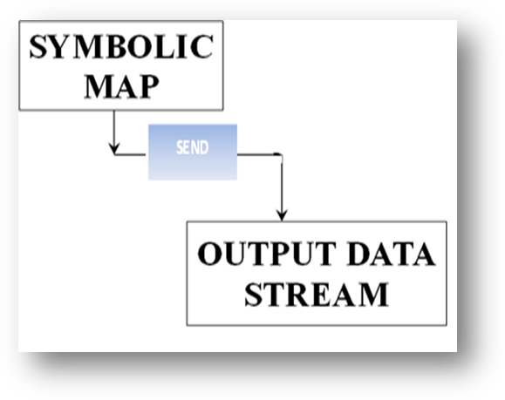

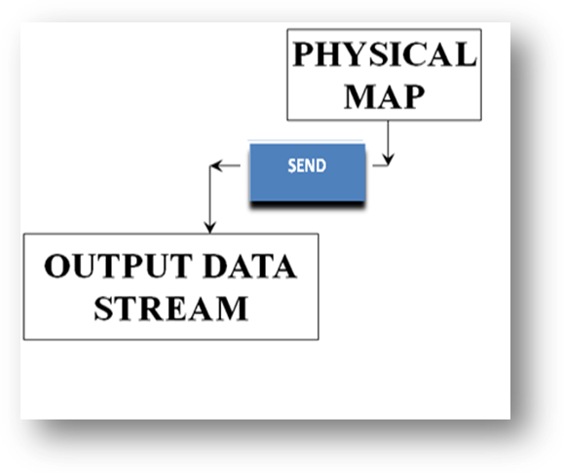
Figure 11: Function of SEND MAP Command
FREEKB: To free the keyboard
ALARM: To make an alarm sound
FRSET: To reset MDT to zero (i.e. not modified) for all unprotected fields of the screen
DATAONLY: Only application program data in the symbolic map is to be sent to the terminal. The attribute character must be provided for each field.

EXEC CICS
SEND MAP (‘MAP1’)
MAPSET (‘MAPSETA’)
DATAONLY
END-EXEC.

EXEC CICS
SEND MAP (‘MAP1’)
MAPSET (‘MAPSETA’)
END-EXEC.

MAPONLY: Only the default data from the physical map is to be sent to the terminal.If this option is specified, FROM option must be specific.
EXEC CICS
SEND MAP (‘MAP1’)
MAPSET (‘MAPSETA’)
MAPONLY
END-EXEC.

SEND CONTROL Command
The SEND CONTROL command is used by an application program to dynamically establish the dynamic
Control options without actually sending a map.

COMMON ERRORS WITH MAPS
    - MAPFAIL
- More predominant error
- Normally occurs when there is no data to be transmitted but the user uses any AID keys and receives the input
    - INVREQ
      - Receive Command executed without a map on the screen.
    - INVMPSZ
      - Size of the map specified is larger than the screen.

COPY BOOKS TO BE INCLUDED FOR USING BMS
.........
WORKING-STORAGE SECTION.
COPY DFHAID.
//TO USE FUNCTION KEY RESPONSES
COPY DFHBMSCA.
//BMS COMMON WORK AREA
COPY SYMBMAP1.
//USER DEFINED MAP
PROCEDURE DIVISION.
....

Sessions 18: Screen Definition Facility (SDF)

SDF is interactive screen definition software which works under CICS or TSO.This is an additional product supplied by IBM.

18.1 Advantages of using SDF
- Interactive and direct definition of Screens on Terminals.
- SDF automatically generates BMS macro code. So programmers are relieved from the troubles of coding Assembler macros.
- Provides interactive TEST facility.
- Provides some additional utilities like COPY, DELETE, RENAME functions & Directory Listing.

Sessions 19: Exception Handling
An abnormal situation can arise during the execution of a CICS command. This is known as an “exception condition”. Each CICS command has its own set of possible exception conditions. It is strongly recommended to check possible exception conditions after every CICS command.

- Exceptional Condition is generated when a CICS command encounters an unusual situation
  - Task is abnormally terminated
  - An Abend code is displayed that identifies the exceptional condition
- CICS provides a number of programming options applicable to each choice mentioned BELOW
  - RESP
  - HANDLE CONDITION
  - IGNORE CONDITION
  - HANDLE AID
  - HANDLE ABEND
19.1 Exceptional Condition Abend codes
Abend CODE | Explanation
AEIK | TERMIDERR
AEIM | NOTFND
AEIO | DUPKEY
AEIQ | IOERR
AEY7 | NOTAUTH
APIA | ERROR
AEID | EOF
AEIM | NOTFND
AEIN | DUPKEY
AEIP | INVREQ
AEIQ | IOERR
AEIR | NOSPACE
AEIS | NOTOPEN
AEIT | ENDFILE
AEIV | LENGERR
AEIW | QZERO
AEIZ | ITEMERR
AE19 | MAPFAIL
AEYH | QIDERR

Following are the common ABEND codes not related to exceptional conditions.
AEY7 --Resource security failed.
AEY9 --Unsupported command issued.
AKCS --Deadlock or timeout
ASRB ABEND due to OS ABEND intercepted by CICS.
ASRA ABEND due to program interruption (error in COBOL statement).

19.2 RESP OPTION
The RESP option can be specified in any CICS command. Its function is similar to the return code in a batch program. If the RESP option is specified in a command, CICS places a response code at the completion of the command. The application program can check this code, and then proceed to the next processing. CICS has a built-in function called DFHRESP that enables us to test the RESP value symbolically. This makes coding easier as we do not have to remember the numerical value of numerous response codes.
If WS-RESP = DFHRESP (NORMAL)
If WS-RESP = DFHRESP (LENGERR)
Alternatively we can look up the numerical value of EIBRESP associated with these conditions and code the above statements as:
If WS-RESP = 00
If WS-RESP = 22
For a list of EIBRESP codes with their symbolic equivalents, refer to the below table:
Condition | Value | Condition | Value
NORMAL  NOTFND  DUPREC  INVREQ  NOSPACE  NOTOPEN  ENDFILE  LENGERR  QZERO | 00  13  14  16  18  19  20  22  23 | QBUSY  ITEMERR  PGMIDERR  ENDDATA  MAPFAIL  QIDERR  ENQBUSY  DISABLED | 25  26  27  29  36  44  55  84

This approach has an advantage over the HANDLE CONDITION approach, because this makes the program more structured.
Procedure to use the RESP option in a CICS command
- Define a full word binary field (S9 (8) COMP) in the Working Storage Section as the response field.
- Place the RESP option with the response field in a command.
- After command execution, check the response code in the response field with DFHRESP(xxxx), where xxxx is :
  - NORMAL for normal completion.
  - Error for any exceptional condition.

Example :
WORKING-STORAGE SECTION.
77 WS-RETCODE PIC S9(8) COMP.
PROCEDURE DIVISION.
.
.
EXEC CICS SEND
FROM (_____)
LENGTH(___)
ERASE
RESP(WS-RETCODE)
END-EXEC.
.
IF WS-RETCODE = DFHRESP(NORMAL)
GO TO NORMAL-PARA.
IF WS-RETCODE = DFHRESP(LENGERR)
GO TO LENGERR-PARA.
GO TO GENERAL-ERR-PARA.
NORMAL-PARA.
LENGERR-PARA.

During the execution of this program, the following functions are to occur:

- At the completion of the SEND command, the WS-RETCODE field will have the response code of the command execution result.
- If the SEND command completes normally, control will be passed to NORMAL-PARA.
- If a LENGERR is encountered, control will be passed to LENGERR-PARA.
- Other exceptions are :
  - PGMIDERR – Program not found
  - LENGERR – Load module > 32 K
  - NOAUTH – Security check error

- If any other exceptional condition is encountered, control will be passed to GENERAL-ERR-PARA.
- General EXCEPTIONS are:
  - LENGERR – Record length mismatch with file
  - INVREQ – Read operation not permitted as it is not mentioned in the FCT. Record is locked
  - NOAUTH – Resource acquisition failed
  - NOTFND – Record not found
  - ENDFILE – End of File
  - QIDERR - DCT entry not found for the ‘Q’
  - NOSPACE - no space available in TDQ
  - QZERO - no more items to read in the ‘Q’

19.3 HANDLE CONDITION COMMAND
To pass control to a specified label. Although the use of the RESP option is recommended in handling program conditions, CICS HANDLE CONDITION command is another method of handling various anticipated or unexpected CICS conditions.

EXEC CICS HANDLE CONDITION
ERROR (ERROR-MESSAGE)
END-EXEC

The HANDLE Condition command is executed prior to the condition being encountered, whereas the results of the results of the RESP option are tested after execution of a CICS command.

HANDLE CONDITION - SCOPE
- Remains active
    - Until an IGNORE Condition
    - Another HANDLE CONDITION for the same error
    - Deactivated by NOHANDLE Option in commands

HANDLE CONDITION COMMAND

EXEC CICS HANDLE CONDITION
Exception Condition1 (ROUTINE 1)
Exception Condition2 (ROUTINE 2)
Exception Condition3 (ROUTINE 3)
END-EXEC.

Syntax:
EXEC CICS HANDLE CONDITION
ERROR(GEN-ERR-RTN)
LENGERR(LENGERR-RTN)
END-EXEC.

MOVE 40 TO WS-LENGTH.

EXEC CICS RECEIVE
INTO (WS-INPUT)
LENGTH (WS-LENGTH)
END-EXEC.

LENGERR-RTN.
........................................
GEN-ERR-RTN.
.............................................

19.4 IGNORE CONDITION COMMAND
The IGNORE CONDITION command causes no action to be taken if the specified condition occurs in the program. The control will be passed on to the instruction following the command which is encountered the exceptional condition.
IGNORE CONDITION - SCOPE
  - applies only to the program in which it is specified
  - active while the program is being executed
  - active until a HANDLE CONDITION command for the same condition is encountered,
Syntax:
EXEC CICS IGNORE CONDITION
condition
(condition)
END-EXEC.

The “condition” indicates an exceptional condition. At the most, only 16 conditions are allowed in the same command.

EXEC CICS IGNORE CONDITION
LENGERR
END-EXEC.
EXEC CICS RECEIVE
INTO (_______)
LENGTH (____)
END-EXEC.

- At the execution of the RECEIVE command, if LENGERR exception occurs, the condition will be ignored, and the control will be passed to the statement after the RECEIVE command.
The NOHANDLE option
Another technique is used for ignoring program conditions that occur when a CICS command is executed. The NOHANDLE option may be coded on any CICS command to ignore any condition that occurs upon execution of that command. This option applies only to the CICS command on which it is included. The use of the RESP option implies NOHANDLE. NOHANDLE overrides the HANDLE AID command, and tests for PF keys are ignored. The NOHANDLE option can be coded as follows:
EXEC CICS RECEIVE
INTO (WS-INPUT)
LENGTH (WS-LENGTH)
NOHANDLE
END-EXEC.

19.5 HANDLE AID COMMAND
- Used to execute a routine depending on a key pressed
- Always used with RECEIVE command

Syntax:
EXEC CICS HANDLE AID
attention id1 (ROUTINE1)
attention id2 (ROUTINE2)
attention id3 (ROUTINE3)
END-EXEC.

Example:

EXEC CICS HANDLE AID
PF3(END-ROUTINE)
PA1(CANCEL-ROUTINE)
ENTER(NORMAL-ROUTINE)
ANYKEY(WRONG-KEY-ROUTINE)
END-EXEC.

HANDLE ABEND COMMAND
- HANDLE ABEND

19.6 HANDLE ABEND
- Used to intercept an abnormal termination (ABEND) in a program
- Used to activate, cancel or reactivate an exit for the ABEND processing.

The HANDLE CONDITION command intercepts the abnormal conditions of the CICS command execution whereas HANDLE ABEND intercepts abnormal termination.
Syntax:
EXEC CICS HANDLE ABEND
[PROGRAM(name) |
LABEL(label) |
CANCEL |
RESET ]
END-EXEC.

PROGRAM or LABEL is used to pass control to a program or a paragraph, respectively, for ABEND processing.
CANCEL is used to cancel the previously established HANDLE ABEND request.
RESET is used to reactivate the previously cancelled HANDLE ABEND request.

During the execution of the below program, the following activities will occur:
- If an ABEND occurs, it will be intercepted by the HANDLE ABEND command, and control will be passed to ABEND-ROUTINE.
- At the completion of the HANDLE ABEND/CANCEL command, the previous HANDLE ABEND request will be cancelled.
- At the completion of the ABEND command, the task will be terminated with user code ‘9999’.

WORKING-STORAGE SECTION.
77 MSG-LEN PIC S9(4) COMP.
01 MSG-DATA.
05 MSG-DATA1 PIC X(15).
05 MSG-DATA2 PIC X(50).
:
PROCEDURE DIVISION.
:
EXEC CICS HANDLE ABEND
LABEL(ABEND-ROUTINE)
END-EXEC.
:
ABEND-ROUTINE.
MOVE ‘ABEND OCCURED.’ TO MSG-DATA1.
MOVE ‘TASK CANCELLED WITH ABCODE 9999.’ TO MSG-DATA2.
MOVE 65 TO MSG-LEN.
EXEC CICS SEND
FROM (MSG-DATA)
LENGTH(MSG-LEN)
NOHANDLE
END-EXEC.
EXEC CICS HANDLE ABEND
CANCEL
END-EXEC.
EXEC CICS ABEND
ABCODE(‘9999’)
END-EXEC.

HANDLE CONDITION and IGNORE CONDITION commands remain in effect until program ends.

Sessions 20: PUSH & POP
PUSH AND POP commands are used to suspend and reactivate all the HANDLE CONDITION requests.

EXEC CICS HANDLE CONDITION
LENGERR(LENG-ERR-PARA-1)
END-EXEC.
EXEC CICS RECEIVE
INTO(WS-INPUT)
LENGTH(WS-LENGTH)
END-EXEC.
PERFORM PARA-A.
EXEC CICS SEND
FROM(WS-OUTPUT)
LENGTH(WS-LENGTH)
END-EXEC.

PARA-A.
EXEC CICS PUSH HANDLE END-EXEC
EXEC CICS HANDLE CONDITION
LENGERR(LENG-ERR-PARA-2)
END-EXEC.
EXEC CICS RECEIVE INTO(WS-INPUT)
LENGTH(WS-LENGTH)
END-EXEC.
EXEC CICS POP HANDLE END-EXEC.

HANDLE ABEND Command
EXEC CICS ABEND
[ABCODE(name)]
END-EXEC
e.g.:-
EXEC CICS ABEND
ABCODE(‘ERR1’)
END-EXEC

EXEC CICS HANDLE ABEND
[PROGRAM (name) | LABEL(label) | CANCEL | RESET]
END-EXEC

Sessions 21: CICS – Testing and Debugging

21.1 Master Terminal Transaction (CEMT)
- CEMT transaction is a CICS supplied transaction which manipulates the CICS environment, such as transactions, programs, files, TSQs and tasks
- CEMT performs following major functions:
  - INQUIRE: To inquire about the status of CICS environments
  - SET: To update the status of CICS environments
  - PERFORM: For performing system operations
- To initiate, type CEMT and press ‘Enter’ key. The response will be
  - STATUS: ENTER ONE OF THE FOLLOWING
  - INQUIRE
  - PERFORM
  - SET
- Select a function by typing INQ, PER or SET. If the selection is INQ or SET the response will be
  - STATUS: ENTER ONE OF THE FOLLOWING
  - TRANSACTION TRA
  - PROGRAM PRO
  - DATASET DA
- To force a new copy of a program or a map
  - CEMT SET PROGRAM (name) NEWCOPY
- To open or close a file
  - CEMT SET FILE (name) {OPEN | CLOSE}
- To check on the status of a file, program, or transaction
  - CEMT INQUIRE {FILE (name) | PROGRAM (name) | TRANSACTION (name) }

21.2 CECI (Command Level Interpreter)
- CECI is a CICS supplied transaction which performs syntax checking of a CICS command
- If the syntax is satisfied, the command can be executed.
- CECI enables the programmer to execute CICS commands without writing a program.
- To invoke CECI, type CECI with the command to be interpreted
CECI - Example
- Useful for displaying initial map contents and for executing many CICS command without writing a program
CECI
SEND MAP (‘MAPSMP’)
MAPSET(‘MAPSETS’)
ERASE

21.3 Execution Diagnostic Facility (EDF)
- EDF is the tool provided by CICS for debugging CICS applications
- EDF monitors an application program by executing the program with many interrupt points
- EDF displays various information about the status of CICS Command execution at these interrupt points

21.4 EDF - Interrupt Points
- EDF allows program interruption at the following places
- At transaction initiation
- At start of each CICS command
- At completion of each CICS command
- At program termination
- At normal task termination
- At abnormal task termination
- EDF does not allow interruption at COBOL statements

21.4.1 Information Available at Interrupt Points
- Contents of EIB Block
- Program’s working storage area
- Last ten commands executed
- Current, next or previous application screen
- Contents of Temporary Storage Queue
- Contents of any address location within CICS

21.4.2 EDF - Interacting with program
- At ‘ABOUT TO EXECUTE COMMAND’
- The argument values of a CICS command can be modified
- The CICS command can be suppressed
- At ‘COMMAND COMPLETION’
- The argument values can be modified
- The return code can be modified
- At any interrupt point
- The working storage values can be modified
- The contents of many EIB fields can be modified

21.4.3 EDF - Other options
- At any time, EDF mode can be cancelled and normal execution can be resumed
- ‘STOP CONDITIONS’ can be requested to suspend the task at specified CICS commands

21.4.4 EDF Invocation
- Application program must have been translated with the DEBUG option
- User must have execution authority for the transaction id CEDF
- CICS Supplied Transaction CEDF initiates an EDF session
- Execution results can be viewed in the same terminal screen or in a different screen
  - Terminal ID to be given as a parameter for latter case

EDF - Program initiation Screen
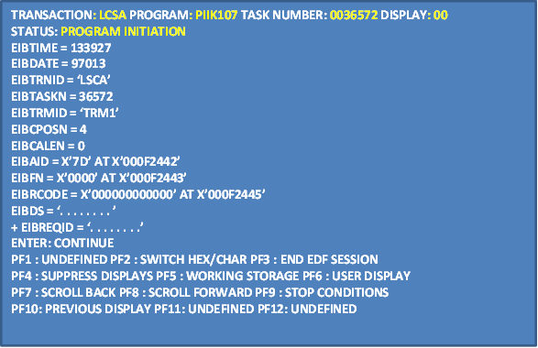

EDF – ‘About to execute command’ Screen
TRANSACTION: LCSA PROGRAM: PIIK107 TASK NUMBER: 0036572 DISPLAY: 00
STATUS: ABOUT TO EXECUTE COMMAND
EXEC CICS WRITE FILE
FILE ('LAILUDQ ')
FROM ('A0ABNCH109364 5..2223 122222A0AB MAXRCV '...)
LENGTH (500)
RIDFLD ('A0AB')
NOHANDLE
OFFSET:X'017A7C' LINE:14697 EIBFN=X'1206'
ENTER: CONTINUE
PF1 : UNDEFINED PF2 : SWITCH HEX/CHAR PF3 : UNDEFINED
PF4 : SUPPRESS DISPLAYS PF5 : WORKING STORAGE PF6 : USER DISPLAY
PF7 : SCROLL BACK PF8 : SCROLL FORWARD PF9 : STOP CONDITIONS
PF10: PREVIOUS DISPLAY PF11: UNDEFINED PF12: ABEND USER TASK

EDF-‘Command Execution Complete’ Screen

EDF-‘Command Execution Complete’ Screen
TRANSACTION: LCSA PROGRAM: PIIK107 TASK NUMBER: 0036572 DISPLAY: 00
STATUS: COMMAND EXECUTION COMPLETE
EXEC CICS WRITE FILE
FILE ('LAILUDQ ')
FROM ('A0ABNCH109364 5..2223 122222A0AB MAXRCV '...)
LENGTH (500)
RIDFLD ('A0AB')
NOHANDLE
OFFSET:X'017A7C' LINE:14697 EIBFN=X'1206'
RESPONSE : NORMAL EIBRESP=0
ENTER: CONTINUE
PF1 : UNDEFINED PF2 : SWITCH HEX/CHAR PF3 : UNDEFINED
PF4 : SUPPRESS DISPLAYS PF5 : WORKING STORAGE PF6 : USER DISPLAY
PF7 : SCROLL BACK PF8 : SCROLL FORWARD PF9 : STOP CONDITIONS
PF10: PREVIOUS DISPLAY PF11: UNDEFINED PF12: ABEND USER TASK

EDF - ‘Stop condition’ Command
TRANSACTION: LCSA PROGRAM: PIIK107 TASK NUMBER: 0036572 DISPLAY: 00
DISPLAY ON CONDITION:-
COMMAND : EXEC CICS
OFFSET : X’ . . . . . . ‘
LINE NUMBER : . . . . . . . .
CICS EXCEPTIONAL CONDITION :
ANY CICS ERROR CONDITION YES
TRANSACTION ABEND YES
NORMAL TASK TERMINATION YES
ABNORMAL TASK TERMINATION YES
ENTER: CURRENT DISPLAY
PF1 : UNDEFINED PF2 : UNDEFINED PF3 : UNDEFINED
PF4 : SUPPRESS DISPLAYS PF5 : WORKING STORAGE PF6 : USER DISPLAY
PF7 : UNDEFINED PF8 : UNDEFINED PF9 : UNDEFINED
PF10: UNDEFINED PF11: UNDEFINED PF12: REMEMBER DISPLAY

EDF - Working Storage Display
TRANSACTION: LCSA PROGRAM: PIIK107 TASK NUMBER: 0036572 DISPLAY: 00
ADDRESS : 000F2D3C WORKING STORAGE
000F2D30 000000 00000000 . . . . . . . . . . . . . . . .
000F2D40 000004 00000000 00000000 000500F1 F1F1F1F1 . . . . . . . . . . . 11111
000F2D50 000014 001900C1C1C1C1C1 C1C1C1C1 C1C1C1C1 . . .AAAAAAAAAAAAA
000F2D60 000024 00000000 00000000 00000000 00000000 . . . . . . . . . . . . . . . .
000F2D70 000034 00000000 00000000 00000000 00000000 . . . . . . . . . . . . . . . .
000F2D80 000044 00000000 00000000 00000000 00000000 . . . . . . . . . . . . . . . .
000F2D90 000054 00000000 00000000 00000000 00000000 . . . . . . . . . . . . . . . .
000F2DA0 000064 00000000 00000000 00000000 00000000 . . . . . . . . . . . . . . . .
000F2DB0 000074 00000000 00000000 00000000 00000000 . . . . . . . . . . . . . . . .
000F2DD0 000084 00000000 00000000 00000000 00000000 . . . . . . . . . . . . . . . .
000F2DE0 000094 00000000 00000000 00000000 00000000 . . . . . . . . . . . . . . . .
000F2DF0 0000A4 00000000 00000000 00000000 00000000 . . . . . . . . . . . . . . . .
000F2E00 0000B4 00000000 00000000 00000000 00000000 . . . . . . . . . . . . . . . .
000F2E01 0000C4 00000000 00000000 00000000 00000000 . . . . . . . . . . . . . . . .
ENTER: CURRENT DISPLAY
PF1 : UNDEFINED PF2 : UNDEFINED PF3 : UNDEFINED
PF4 : SUPPRESS DISPLAYS PF5 : WORKING STORAGE PF6 : USER DISPLAY
PF7 : UNDEFINED PF8 : UNDEFINED PF9 : UNDEFINED
PF10: UNDEFINED PF11: UNDEFINED PF12: REMEMBER DISPLAY

EDF - ABEND status display
TRANSACTION: LCSA PROGRAM: PIIK107 TASK NUMBER: 0036572 DISPLAY: 00
STATUS: AN ABEND HAS OCCURRED
COMMAREA =
EIBTIME = 133927
EIBDATE = 97013
EIBTRNID = ‘LSCA’
EIBTASKN = 36572
EIBTRMID = ‘TRM1’
EIBCPOSN = 4
EIBCALEN = 0
EIBAID = X’7D’ AT X’000F2442’
EIBFN = X’0000’ AT X’000F2443’
EIBRCODE = X’000000000000’ AT X’000F2445’
EIBDS = ‘. . . . . . . . ’
+ EIBREQID = ‘. . . . . . . .’
OFFSET :X’2A7FEA’ INTERRUPT : DATA EXCEPTION
ABEND : ASRA PSW :X’078D2000 002A7FF0 00060007
ENTER: CONTINUE
PF1 : UNDEFINED PF2 : SWITCH HEX/CHAR PF3 : END EDF SESSION
PF4 : SUPPRESS DISPLAYS PF5 : WORKING STORAGE PF6 : USER DISPLAY
PF7 : SCROLL BACK PF8 : SCROLL FORWARD PF9 : STOP CONDITIONS
PF10: PREVIOUS DISPLAY PF11: UNDEFINED PF12: REGISTERS AT ABEND

EDF - Program termination screen

TRANSACTION: LCSA PROGRAM: PIIK107 TASK NUMBER: 0036572 DISPLAY: 00
STATUS: PROGRAM TERMINATION
ENTER: CONTINUE
PF1 : UNDEFINED PF2 : SWITCH HEX/CHAR PF3 : END EDF SESSION
PF4 : SUPPRESS DISPLAYS PF5 : WORKING STORAGE PF6 : USER DISPLAY
PF7 : SCROLL BACK PF8 : SCROLL FORWARD PF9 : STOP CONDITIONS
PF10: PREVIOUS DISPLAY PF11: UNDEFINED PF12: ABEND USER TASK

EDF - Task termination
TRANSACTION: LCSA PROGRAM: PIIK107 TASK NUMBER: 0036572 DISPLAY: 00
STATUS: TASK TERMINATION
TO CONTINUE EDF SESSION REPLY YES REPLY : NO
PF1 : UNDEFINED PF2 : SWITCH HEX/CHAR PF3 : END EDF SESSION
PF4 : SUPPRESS DISPLAYS PF5 : WORKING STORAGE PF6 : USER DISPLAY
PF7 : SCROLL BACK PF8 : SCROLL FORWARD PF9 : STOP CONDITIONS
PF10: PREVIOUS DISPLAY PF11: UNDEFINED PF12: REGISTERS AT ABEND

21.5 Temporary Storage browse (CEBR)
- CEBR is used to browse the information in Temporary Storage Queue
- VS COBOL II places ABEND information in the default TSQ (If the program was compiled with the FDUMP option)
- Lets write contents of TSQ to a TDQ or read contents of TDQ into the TSQ
CEBR Syntax
- CEBR [queue-name]
- When CEBR is entered, the default TS queue is assigned automatically.
- Default TSQ name starts with ‘CEBR’ and ends with the CICS terminal id
- If terminal is L1T4 then default queue name is CEBRL1T4
CEBR - Reading a TDQ
CEBR TS QUEUE CEBRPV04 RECORD 1 0F 0 COL 1 OF 0
ENTER COMMAND ---> GET TD01
*************************************************************************
***************************BOTTOM OF QUEUE***************************
TEMPORARY STORAGE QUEUE CEBRPV04 IS EMPTY
PF1 : HELP PF2 : SWITCH HEX/CHAR PF3 : TERMINATE BROWSE
PF4 : VIEW TOP PF5 : VIEW BOTTOM PF6 : REPEAT LAST FIND
PF7 : SCROLL BACK HALF PF8 : SCROLL FORWARD HALF PF9 : UNDEFINED
PF10: SCROLL BACK FULL PF11: SCROLL FORWARD FULL PF12: UNDEFINED

CEBR – Reading a TDQ (Output)
CEBR TS QUEUE CEBRPV04 RECORD 1 0F 1 COL 1 OF 20
ENTER COMMAND --->
*************************************************************************
00001 TEST DATA RECORD ONE
***************************BOTTOM OF QUEUE***************************
PF1 : HELP PF2 : SWITCH HEX/CHAR PF3 : TERMINATE BROWSE
PF4 : VIEW TOP PF5 : VIEW BOTTOM PF6 : REPEAT LAST FIND
PF7 : SCROLL BACK HALF PF8 : SCROLL FORWARD HALF PF9 : UNDEFINED
PF10: SCROLL BACK FULL PF11: SCROLL FORWARD FULL PF12: UNDEFINED

Sessions 22: File handling

The CICS File control program (FCP) provides application programs with services to read, update, add, and delete records in a file. In addition, it makes application programs independent of the structure of the database, while it manages exclusive control over the records in order to maintain the data integrity during record updates.
CICS
- Supports VSAM
  - BDAM supported in earlier versions of CICS
- Files to be defined to CICS in a table called the file control table (FCT) [Some FCT entries are: dataset name: access method ; and permissible file service requests such as update, browse, add and delete. Need to specify dataset name , key field, and the data-area name of a record’s I/O area]
- File Opening, Closing done by CICS using Master Terminal Transaction ( CEMT)
- Creates VSAM cluster using JCL
- Use symbolic file name in the program
- During Update, a program gets exclusive control over the record being updated
- Provides interface for
  - Random access
  - Sequential access
  - Read, Write, Update, Delete

22.1 File Control Service
Data independence is a concept of program being independent of structure of data access methods.
CICS File Control provides data independence to application programs, so programmer does not have to be concerned with data dependent COBOL parameters or JCL as-
- INPUT-OUTPUT SECTION
- SELECT statement
- FD entry
- OPEN/CLOSE
- JCL

22.2 File Access Methods
- VSAM is the primary data access method for CICS
- VSAM file types supported
  - Key Sequenced Data Set (KSDS)
  - Entry Sequenced Data Set (ESDS)
  - Relative Record Data Set (RRDS)

22.2.1 Entry Sequenced Data Set (ESDS)
In a VSAM ESDS, records are maintained in the file in the sequence in which they are added. Typically, the records are added at the end of the data set.
- A record is identified for retrieval by its displacement from the beginning of the data set - It is known as the Relative Byte Address (RBA).
- Records can be updated but their length cannot change.
- Records cannot be deleted.

22.2.2 Key Sequenced Data Set (KSDS)
The organization of a KSDS data set includes an index (primary index) and a data component.
Records can be accessed using a key which has a fixed length and position within each record. Records can also be retrieved using RBA.
Records can be read sequentially or randomly.
Records are created within the file based on the key value. The records can also be updated or deleted.
Alternate indexes and paths can be defined for accessing the file in a different order than the primary index order.

22.2.3 Relative Record Data Set (RRDS)
The data set consists of a number of fixed length slots, which are sequenced in ascending relative -record number.
A slot can contain record data or it can be empty.
Records can be accessed sequentially or directly by the Relative Record Number (RRN).

22.3 Record identification (RIDFLD)
- RECORD KEY
- PARTIAL KEY
- RELATIVE BYTE ADDRESS (RBA)
- RELATIVE RECORD NUMBER (RRN)
For accessing the VSAM files, the key field known as the record identification field (RIDFLD) is required.
The RIDFLD contains the key of the record to be read. Its format and contents vary depending on the VSAM file organization.
- For KSDS files, the key specified can be a full key value or a partial key, also known as the Generic Key. The length of the generic key must be provided when using the partial (generic) key. In addition the relative byte address can also be used, instead of the actual key value.
- For ESDS, RIDFLD contains a four byte binary RBA.
- For RRDS, RIDFLD contains a four byte binary relative record number.

22.4 VSAM File – Random Access
To employ the Random Access the following activities need to be performed:
- READ
- WRITE a new record
- REWRITE a record previously ‘read for update’
- DELETE
- UNLOCK a record previously ‘read for update’

22.5 VSAM File – Sequential Access
To employ the Sequential Read (Browsing) the following activities need to be performed:
- Start Browsing
- Read Next
- Read Previous
- End Browsing
- Reset Browsing conditions

22.6 VSAM - READ from File
DATASET is the name of the file which has to be read. This is the symbolic file name which identifies the FCT entry for the file.
INTO is the name of the data area into which the record is to be read. It is
a structure defined in the working storage of the application program.
LENGTH is the maximum number of characters that may be read into rec-area. It must be defined as half-word binary. COBOL II does not require a length option if the records are fixed length.
RIDFLD is the data area containing the key value of the record to be read.
GENERIC For partial key requests, the GENERIC option can be used. Thelength of the partial key must be specified in KEYLENGTH option.
EQUAL means only record whose key exactly matches the key specified in RIDFLD must be read.
GTEQ means the first record whose key greater than are equal to the key specified in RIDFLD must be read.
UPDATE Record is read for updating or deletion later.
RBA Specifies that the file is ESDS and the RIDFLD option should be interpreted as the Relative Byte Address.
RRN Specifies that the file is RRDS

EXEC CICS READ DATASET(file-name)
INTO (rec-area)
LENGTH(record_length)]
RIDFLD(key-value)
RBA | RRN]
GENERIC]
KEYLENGTH(key-length)]
[UPDATE]
[GTEQ | EQUAL]
END-EXEC.

VSAM - READ from FILE: Syntax

WORKING- STORAGE SECTION.
77 WS-REC-LEN PIC S9(4) COMP.
77 WS-FILE-NAME PIC X(8) VALUE ‘ACCTMSTR’
01 WS-FILE-REC
05 WS-REC-KEY PIC X(6).
05 WS-REC-DATA PIC X(34).
PROCEDURE DIVISION.
MOVE 40 TO WS-REC-LEN.
MOVE ‘ABC451’ TO WS-REC-KEY.
EXEC CICS READ DATASET(WS-FILE-NAME)
INTO (WS-FILE-REC)
RIDFLD(WS-REC-KEY)
LENGTH(WS-REC-LEN)
END-EXEC.

The file ‘TRNMSTR’ should have been registered in FILE Control Table (FCT) in CICS and must be enabled.
After execution WS-FILE-REC will have the data record read from
‘TRNMSTR’ whose key value is ‘ABC451’.

VSAM – Steps to Add New Records

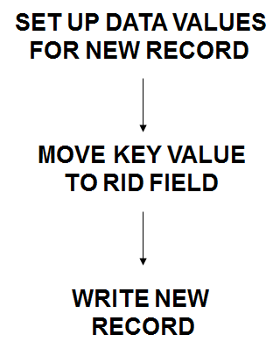
Figure 12: Add new records in KSDS

22.7 VSAM – Write to File
RIDFLD Specifies the key of the record to be written. If RBA or RRN is specified, this field is interpreted as a Relative Byte Address or Relative Record Number respectively.
RBA Specifies that the file is ESDS and the RIDFLD option should be interpreted as the Relative Byte Address.
RRN Specifies that the file is RRDS and the RIDFLD option should be interpreted as the Relative Record Number.

EXEC CICS WRITE
DATASET(file-name)
FROM(file-rec)
LENGTH(rec-length)
RIDFLD(rec-key)
[RBA | RRN]
END-EXEC

22.8 VSAM - File Update
The REWRITE command is used to update a record already read. Before issuing a REWRITE command, READ command must have been issued with the UPDATE option. The key field in the record cannot be changed.

DATASET Specifies the name of the file which has to be updated.
FROM Specifies the data-area from which the data is to be written.
LENGTH Is a binary half-word that indicates the length of the record to be re-written. Not required for VS COBOL II if the file is of fixed-length.
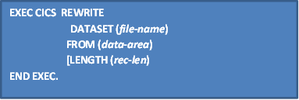

22.9 VSAM – File Unlock
To release a record previously read for update

EXEC CICS UNLOCK
FILE / DATASET (name)
END-EXEC.

22.10 VSAM - Delete from File
The DELETE command may be issued to delete record(s) from a data set in two ways:
- Issued after a READ command with the UPDATE option to delete the record that is read.
- Issued with the RIDFLD option when there is no prior READ with UPDATE option. This will delete the record whose key matches with the RIDFLD.
Records from VSAM KSDS and RRDS files can be deleted, but not from VSAM ESDS files.
The NUMREC option will return the number of records deleted on a GENERIC delete.
KEYLENGTH must be specified for a GENERIC delete.
EXEC CICS DELETE
DATASET (file-name)
RIDFLD(rec-key)
[KEY-LENGTH(key-length)
[GENERIC[NUMREC(rec-number)]]
[RBA | RRN]
END-EXEC.

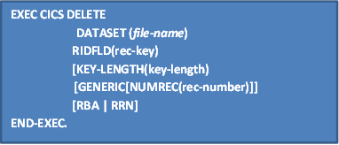

22.11 VSAM - BROWSE Operation
The browse operation is used for fetching the records sequentially from the underlying VSAM file based on selection criteria.

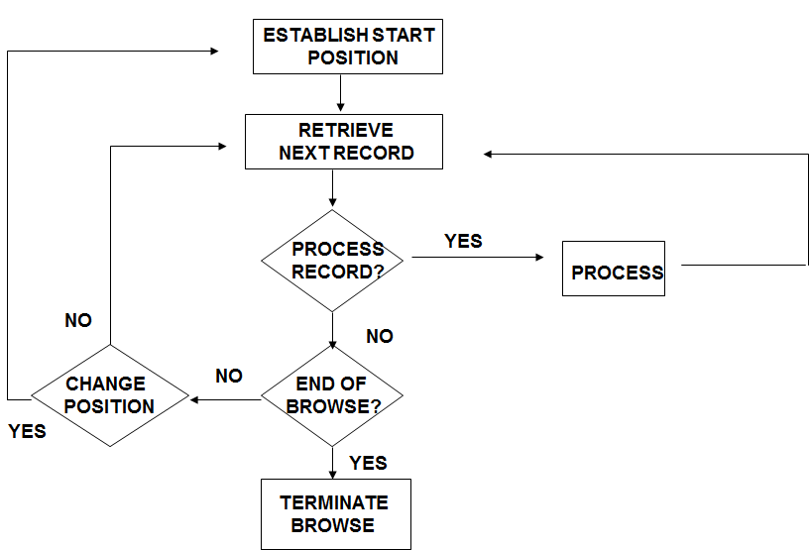
Figure 13: Read/Browse Operation in VSAM

The browse operation consists of three steps:

- Establish the position from where to begin the sequential retrieval.
- Retrieve records sequentially and process them as required.
- Terminate the browse when no further sequential retrieval is required.
The starting position for browse may be re-established at any time during the browse operation.
A record that has been retrieved as part of a browse cannot be updated during browse. For that, browse operation should be terminated and the record should be read again with update option.

22.11.1 VSAM - BROWSE Commands
STARTBR - Establish starting position within file
READNEXT - Retrieve records in ascending order sequentially as set by STARTBR
READPREV - Retrieve Records in descending (reverse) order as set by STARTBR
RESETBR - Restart Browse by re-positioning the pointer
ENDBR - Terminate Browse

STARTBR The STARTBR command establishes the position within the file, but does not retrieve a record.
READNEXT The READNEXT command retrieves the records sequentially in the order set by the STARTBR command. The RIDFLD is automatically updated by CICS for the next READ; application programs NEED NOT update this. RIDFLD can be set to a value greater than the present RIDFLD that is fetched. If a READNEXT is performed in this manner, it is called ‘skip sequential processing’.
READPREV The READPREV command retrieves records in the reverse order as set by the STARTBR command.
ENDBR Terminates the browse operation. Normally not required, but recommended for efficiency sake as the ENDBR will release the VSAM resources allocated for the browsing.
RESETBR To restart browsing from a different file location. This is similar to an ENDBR followed by a STARTBR, but is more efficient because the VSAM resources will be re-allocated rather than de-allocation and fresh allocation.
The key field is updated after every browse retrieval with the actual key of the record retrieved.
ENDFILE occurs when a read is issued
  - After the last record on the file has been retrieved for READNEXT command
  - After the first record on the file has been retrieved for READPREV command.
The file position can be changed by moving the new key value to the contents of RIDFLD before READNEXT or READPREV command.

MOVE ‘VALUE’ TO KEY-REC
EXEC CICS STARTBR FILE(‘FILEA’)
RIDFLD(RECKEY) RESP(ERR-CODE)
END-EXEC.
IF ERR-CODE = DFHRESP(NORMAL)
PERFORM UNTIL ERR-CODE = DFHRESP(ENDFILE).
PERFORM 2000-REC-FROM-FILE
UNTIL 2000-REC-FROM-FIL-EXIT
EXEC CICS READNEXT FILE(‘FILEA’)
INTO(FILEREC) RIDFLD(RECKEY)
RESP(ERR-CODE)
END-EXEC END-PERFORM
EXEC CICS ENDBR FILE(‘FILEA’) …. END-EXEC
ELSE
PERFORM 9000-HANDLE-ERROR …..
END-IF.

Sessions 23: File Handling - Exceptional Conditions

- Processing Information
  - NOTFND
  - ENDFILE
  - LENGERR
- Application Program Error
  - INVREQ
  - FILENOTFOUND
  - ILLOGIC
  - DUPREC
- External Conditions
  - IOERR
  - DISABLED
  - NOTOPEN
- NOSPACE

NOTFND Record with specified key is not found.
ENDFILE Raised when reaching the end of the file on a browse.
LENGERR The length of the record to be rewritten is either too long or not specified.
INVREQ There are several reasons for this exception condition
- No previous READ UPDATE issued for REWRITE.
- Second REWRITE issued before releasing the exclusive control of the first REWRITE.
FILENOTFOUND File name is not in FCT.
ILLOGIC This identifies VSAM error not covered by other CICS exceptional conditions. The 2nd byte of the EIBRCODE contains the VSAM error code
DUPREC Raised when an attempt is made to add a record to a file when a record with the same key already exists.
IOERR Unexpected error such as I/O error on disk
DISABLED File has status of disabled.
NOTOPEN File is closed.
NOSPACE There is no space on the file for write or rewrite.

Sessions 24: VSAM Alternate Index
The VSAM Alternate Index (AIX) feature allows one to uniquely locate a record using a different key structure on the same VSAM/KSDS or ESDS file. Most applications of VSAM AIX involve VSAM /KSDS.
For one VSAM/KSDS file, more than one AIX can be created. The original VSAM/KSDS file is called the Base Cluster. The relationship between the Base and Alternate is as follows:
Base | Alternate
Prime key  Base Index | Alternate Key  Alternate Index (AIX)
Base Cluster | Alternate Index Cluster

24.1 Concept of Alternate Index
The data component of Base Cluster has a series of records which consists of the employee number (Prime Key), last name, and other personal profile data. The Base Index is constructed based on the employee number (Prime key) in the numeric order, and point to the corresponding record in the Data component of Base Cluster.
Alternate Index (AIX) is constructed based on the employee’s last name (Alternate key) in the alphabetic order, and points to the corresponding record in the data portion of the AIX Cluster. Note there are three Kennedys, which will cause the duplicate key condition. Each record in the data portion of the AIX cluster has only a pointer to the Base Index so that from the AIX the corresponding record in the Base Cluster can be accessed. This concept makes one able to access the full information of the Base Cluster from AIX, as well as from the Base Index.

24.2 Path
Reading a record in the AIX cluster it does not directly point to the corresponding record in the Base Cluster. Between the AIX cluster and Base Cluster, there is a special linkage mechanism called “Path”, through which the corresponding record in the Base Cluster can be read. Therefore, the Path must be defined and related to the AIX Cluster. Then CICS program reads the Path (not AIX itself) in order to obtain the corresponding record in the Base Cluster.

Alternate Index Cluster
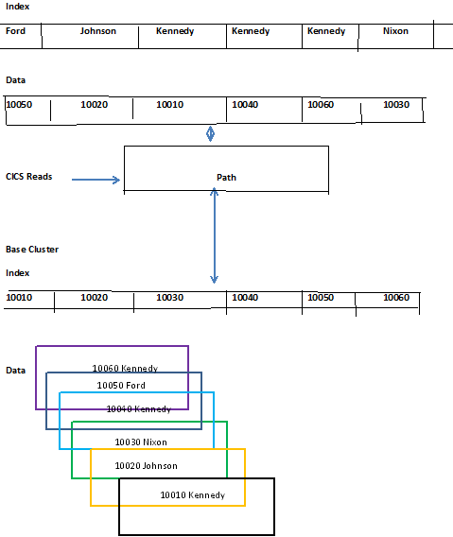
Figure 14: Processing of Files via Alternate Index in KSDS

24.3 Creating AIX
In order to create an Alternate Index, the VSAM utility program (IDCAMS) must be used, in the following way:

1. Create a Base Cluster using the DEFINE CLUSTER command
2. Load data into the Base Cluster using the REPRO command or other commands
3. Create an AIX Cluster using the DEFINE ALTERNATEINDEX command
a. Define the Alternate Key
b. Relate to the Base Cluster
4. Build AIX using the BUILDINDEX command
a. At this point, the AIX Cluster will have the actual data loaded from the Base Cluster
5. Define a Path using the DEFINE PATH command
a. Specify the AIX Cluster as the path entry.
Browsing Operations with AIX and Update Operations for AIX are supported by AIX in KSDS.

Sessions 25: CICS - Database Access

Provides Interface to
- Hierarchical Database - IMS/DB
- Relational Database - DB2

25.1 DB2 Database Access from CICS
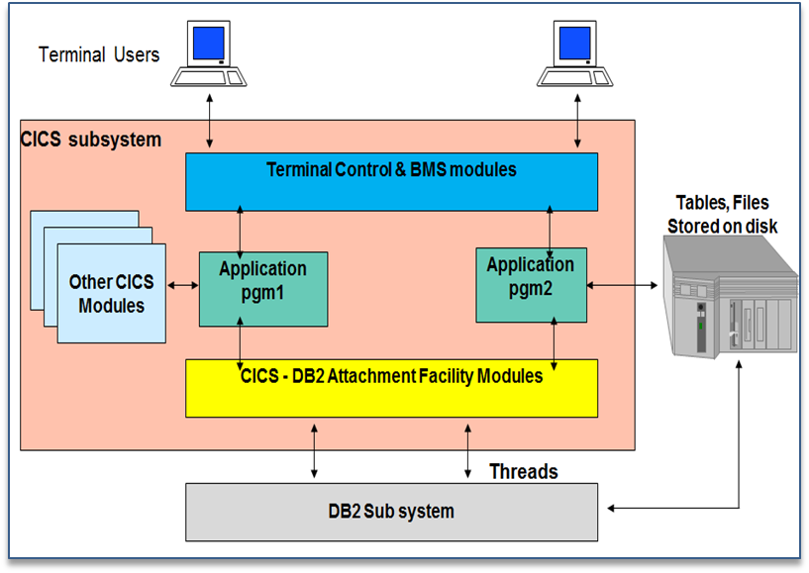
Figure 15: CICS Access of DB2

25.2 CICS DB2 Compilation Process
The steps shown in the below figure summarize how to prepare your program for execution after your application program design and coding is complete.

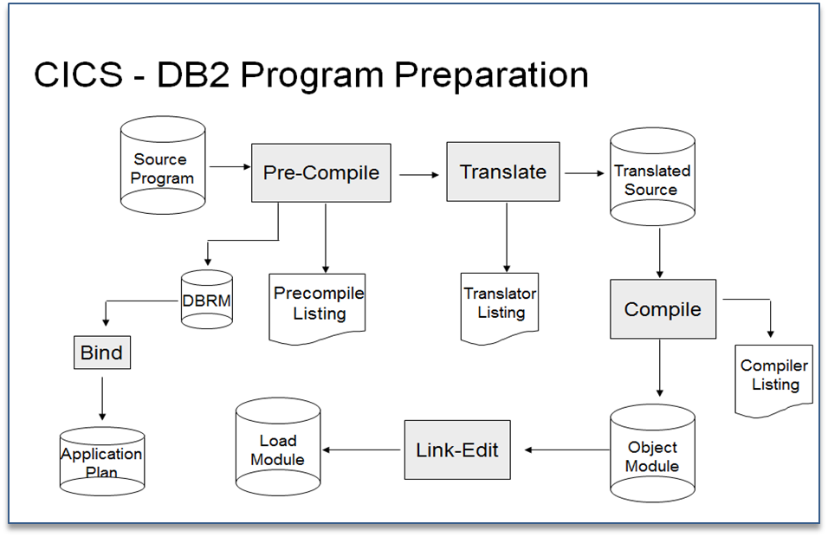

Figure 16: CICS-DB2 Compilation Procedure
Step 1: The DB2 precompiler builds a DBRM that contains information about each of the program's SQL statements. It also validates SQL statements in the program
Step 2: CICS command language translator is executed. The sequence shown is the preferred method, and it is the method supported by the DB2I program preparation panels. If the CICS command language translator is run first, it produces a warning message for each EXEC SQL statement it encounters, but these messages have no effect on the result.
Step 3: Program compilation is done after translation and pre-compilation.
Note :If you are running DB2 Version 7 or later and preparing a COBOL or PL/I program using one of the Language Environment-conforming COBOL or PL/I compilers, the compiler also provides an SQL statement coprocessor (which produces a DBRM), so you do not need to use the separate DB2 precompiler (Step 1).
If you are running DB2 Version 6 or earlier and preparing a COBOL or PL/I program, use the separate DB2 precompiler. For a COBOL program, ensure that you specify a string delimiter that is the same for the DB2 precompiler and the integrated CICS translator. The default delimiters are not compatible.
Step 4: This is the link-edit process in which load module is generated.
Step 5: The bind process requires DB2. The bind process uses the DBRM to produce an application plan (often just called a plan) which enables the program to access DB2 data. Their DBRMs must be bound into the same application plan, or bound into packages that are then listed in the same application plan.

25.3 DL/I DB ACCESS
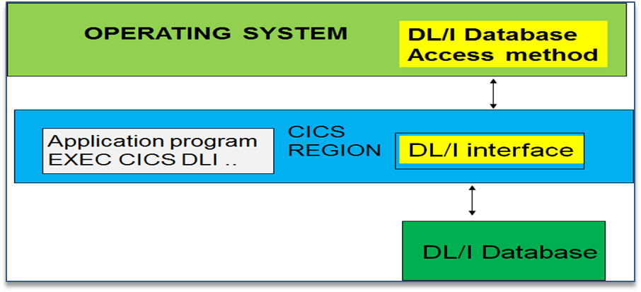
Figure 17: CICS DL/1 DB Access

CICS can access DL/I databases in the following ways:
- Using DBCTL
This is when DBCTL satisfies the DL/I request issued from the CICS system by means of the CICS-DBCTL interface.
Installing and using DBCTL are introduced in this manual (but note that you will also need to refer to other CICS and IMS™ manuals for further information).
- Using remote DL/I
Remote DL/I is done by means of CICS function shipping a DL/I request to another CICS system, in which the DL/I support can be local DL/I (with CICS/ESA 4.1 or below), remote DL/I, or DBCTL. See the CICS Intercommunication Guide for more information on function shipping, and the CICS Transaction Server for z/OS® Installation Guide for information on adding remote DL/I support.

Sessions 26: CICS Queuing Functions

CICS provides a facility to store data that can be considered temporary or transient in nature. These queuing facilities can be used for a number of facilities such as transaction initiation, transaction scratchpad, etc.
26.1 TDQ
Features of Transient Data Control
  - Sequential data sets called Transient Data Files are used by CICS for inter-region and intra-region data transfer
  - This is facilitated by Transient Data Control Program (TDP), which allows CICS transaction to deal with these files
  - Transient Data Files, also called as Transient Data Queue (TDQ) or Transient Data Destination, can be used as either I/P or O/P files, but not both
  - The term Queue is used because records are accessed in sequential mode, as in a queue
  - The Term destination indicates, that most often these sequential data are directed to other transaction or other-wise called Destination
  - Each TDQ is identified by 1-4 character identifier called “Destination -id”, which are to be registered in Destination Control Table (DCT)

26.1.1 Types of TDQs
- INTRAPARTITION TDQ
- EXTRAPARTITION TDQ

26.1.1.1 INTRAPARTITION TDQ
- A group of sequential records which are produced & processed by same and/or different Transactions within a CICS region (Intra).
- All Intrapartion TDQs are stored in only one physical file (VSAM) in CICS region which is prepared by system programmer.
- From application programmers point of view only one record is used at a time sequentially and once record read is logically removed from Queue (Destructive Read).
DFHDCT TYPE = INTRA ,
DESTID=queue-name,
[TRANSID=txn-id-name,]
[TRIGLEV]=number,]
[REUSE=YES|NO]

- DCT entries can be defined using the macro DFHDCT.
TYPE=INTRA Indicates that TDQ is an intrapartition TDQ.

- DESTID Defines the name of the TDQ (1 to 4 chars).
- REUSE Once a record of intrapartition TDQ is read, the record is logically removed. But it still occupies the space. If REUSE = YES is specified, this space for logically deleted record will be used for other TDQ records. But the records are not recoverable. If REUSE=NO, the records are recoverable.
TRANSID & TRIGGER LEVEL Used for automatic task initiation

        - Typical Applications of Intrapartition TDQs
- Interface among CICS Transactions
Prg1 ------ TDQ ------ Application Program ------ Report
- Automatic Task Initiation (ATI)
- Message Routing
- Message Broadcasting

26.1.1.2 EXTRAPARTITION TDQ
- A group of sequential records which interface between Transactions of CICS region and system outside CICS region (Extra).
- In Input Extrapartition TDQ, records are produced by programs outside of CICS region and systems outside of CICS region (Eg: Batch Jobs, TSO, PC ) to be processed by CICS Transaction as I/P.
- In Output Extrapartition TDQ, records are produced by CICS Transaction and are processed by other systems or another CICS region
- Each TDQ is a separate physical file & it may be an disk, tape, printer or plotter. Therefore for its use each file must be opened within CICS region when used by Transaction.
- DCT determines OPEN / CLOSE status of file initially, while file can be opened or closed through Master Terminal Transaction (CEMT) during CICS session.
DFHDCT TYPE = EXTRA ,
DESTID=queue_name,
DSCNAME=name,
[OPEN=INITIAL|DEFERED]

DFHDCT TYPE=SDSCI,
DSCNAME=name,
TYPEFILE=INPUT|OUTPUT|RDBACK

TYPE=EXTRA Indicates it is an Extrapartition TDQ.
DESTID Defines the name of the TDQ (1 to 4 characters).
OPEN Defines the initial file status. If INITIAL is specified the file will be opened at CICS startup time. If DEFERED is specified the file will be closed until it is specifically opened by the CEMT transaction.
DSCNAME Defines the data control block name. For every DSCNAME a corresponding DFHDCT entry must be made with TYPE=SDSCI and the same DSCNAME. This in effect indicates the DDname of the Extrapartition dataset in the JCL of the CICS job.

26.1.1.2.1 Typical Applications of Extrapartition TDQs
- Interface to Batch (or TSO or PC) jobs.
CICS Application Program ------ TDQ ------ File ------ Batch Program
- Interface from Batch (or TSO or PC) jobs.
- Batch Program ------ TDQ ------ File ------ CICS Application Program

Note: TD in command is for Transient Data if omitted Default is TS Temporary Storage Queue.

26.1.2 TDQ- CICS Commands
WRITEQ TD: Writes record in Q for both types.
EXEC CICS WRITEQ TD
QUEUE ( <name> )
FROM ( data-area )
[ LENGTH ( data-value ) ]
END-EXEC.
EXCEPTIONS
QIDERR - DCT entry not found for the ‘Q’
LENGERR - Length specified is greater than maximum length given in DCT
NOSPACE - No space available in TDQ

READQ TD: Read record from Q for both types
EXEC CICS READQ TD
QUEUE ( <name> )
INTO ( data-area )
[ LENGTH ( data-value ) ]
END-EXEC.
EXCEPTIONS
QIDERR - DCT entry not found for the ‘Q’
LENGERR - Length specified is not the same as that specified in DCT
QZERO - No more items to read in the ‘Q’

DELETEQ TD: To delete an Intrapartion TDQ, not valid for Extrapartition TDQ

EXEC CICS DELETEQ TD
QUEUE ( <name> )
END-EXEC.
EXCEPTIONS
QIDERR - DCT entry not found for the ‘Q’

26.1.3 Destination Control Table (DCT)
- DCT`s primary function is to register Control Information of all TD Queues
  - Destination Control Program uses this DCT for identifying all TD Queues and perform input/output operations against them

  - DCT entries are defined using Assembler macros into DFHDCT for both types of TD Queues (parameters & options for both types is quite different)

26.1.4 Automatic Task Initiation (ATI)

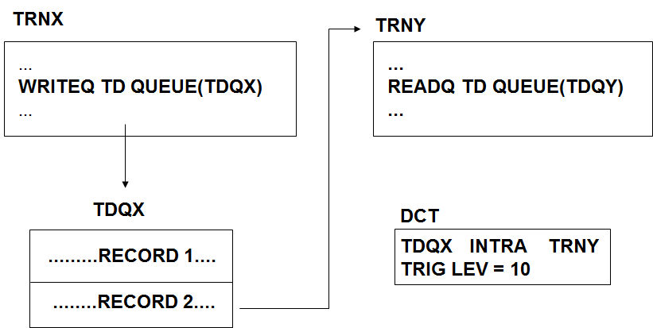

Figure 18: Method of initiation of a Transaction by employing TDQ

- Automatic task initiation (ATI) is a facility through which a CICS transaction can be initiated automatically. When the number of records in an Intrapartition TDQ reaches the trigger level specified, ATI occurs.

- The transaction ID to be triggered must be defined in the DCT entry of the Intrapartition TDQ, with nonzero trigger level.

- In the example, the task TRNX writes into the TDQ - TDQX. The DCT entry for this destination, TDQX, contains TRNY as the transaction ID and trigger level as 10. As soon as the number of records in TDQX reaches 10, the transaction TRNY will be automatically initiated.

26.1.4.1 Application of TDQ
26.1.4.1.1 Message Switching
- Messages are accumulated in TDQ (Intrapartition) and at certain trigger, say 500 messages transaction initiated to route messages.

26.1.4.1.1 Report Print
- Similarly records are accumulated, and at certain trigger other transaction prints these records.

Sessions 27: TSQ

27.1 Features of Temporary Storage Queue

- Area provided by CICS to store data between program executions
- Divided into one or more Temporary Storage queues (TS queues)
- TS queue contains one or more records
- Additional storage facility for a transaction
- Variable length record - Random or Sequential Access
- Records can be updated
- Data In TSQ remains until it is deleted
- Can be used as a scratchpad area
- Each record within a queue is assigned an item number
- Queue IDs need not be predefined – created dynamically
- Queues can be defined as Recoverable

27.1.1 TS Queues - CICS Commands
WRITEQ TS: To add or update a record in a queue

EXEC CICS WRITEQ TS
QUEUE(queue-name)
FROM(data-area)
LENGTH(queue-length)
[ITEM(data-area)]
[REWRITE] [MAIN|AUXILIARY]
END-EXEC
If the specified Queue is not there, it will be created.

QUEUE Specifies the name (1- 8 characters) of the temporary storage where the data is written.
FROM Specifies the data area that contains the record to be written.
LENGTH Specifies the length in binary half-word, of the FROM area.
ITEM Specifies the item number which is being written or updated.
REWRITE Specifies that an existing record as indicated by ITEM is being updated.
MAIN Specifies that the TSQ will reside in the main storage.
AUXILIARY Specifies that the TSQ will reside on disk in the temporary storage file (DFHTEMP).
READQ TS: To retrieve a record from a queue

EXEC CICS READQ TS
QUEUE(queue-name)
INTO (data-area)
LENGTH(data-area)
[ ITEM(data-area) | NEXT ]
[ NUMITEMS(data-area) ]
END-EXEC.

NEXT This option is used to retrieve records sequentially. This option specifies that the next record in the sequence should be read.
ITEM For direct retrieval, you must specify the item number of the record in this option. - Random selection.
NUMITEM If this option is coded, number of items in the queue is placed in this filed.
DELETEQ TS: To delete the entire queue and not individual records
EXEC CICS
DELETEQ TS
QUEUE(queue_name)
END-EXEC.

This command is used to delete all the records in the temporary storage queue and release the associated storage.
It is important to issue this command at the earliest possible time, especially when the main storage is used.
Deleting an individual record in a temporary storage queue is not possible.

27.1.2 TSQs - Exceptional Conditions
ITEMERR The specified item number is not found. In sequential read, this condition occurs if the end of a TSQ is reached.
NOSPACE Sufficient space is not available. The default action is to suspend the task until space becomes available.
QIDERR Queue Name specified in READTS or DELETE TS command is not found.

27.1.3 Temporary Storage Queue - Syntax
In the example shown above, the temporary storage ID is dynamically created. The first four characters contain the terminal id obtained from EIB field EIBTRMID and the last four characters contain the transaction id.

This results in a unique TSQ-ID for a transaction executing at different terminals.
After the WRITEQ TS command is executed, the field WS-TS-ITEM-NO will contain the number of the record just written.
WORKING-STORAGE SECTION.
01 WS-TSQ-DTLS.
05 WS-TS-REC-LEN PIC S9(4) COMP.
05 WS-TS-ERR-CODE PIC S9(8) COMP.
05 WS-TS-ITEM-NO PIC S9(4) COMP.
05 WS-TS-ID PIC X(8).

01 WS-TSQ-DATA PIC X(80).
PROCEDURE DIVISION.
STRING EIBTRMID EIBTRNID DELIMITED SIZE INTO WS-TS-ID
EXEC CICS WRITEQ TS QUEUE(WS-TS-ID)
FROM(WS-TSQ-DATA) LENGTH(WS-TS-REC-LEN)
ITEM(WS-TS-ITEM-NO) RESP(WS-TS-ERR-CODE)
END-EXEC.

IF WS-TS-ERR-CODE NOT EQUAL DFHRESP(NORMAL)
PERFORM 9000-ERROR-PARA
END-IF

Sessions 28: Difference between TDQ and TSQ

TDQ | TSQ
Transient data queue names must be defined in the Transient Data Definitions (TDD) before they are used by an application. TDQ cannot be defined arbitrarily at the time the data is created. Therefore, transient data queues do not have the same dynamic characteristics. | Temporary storage queues do have the same dynamic characteristics
Transient data queues must be read sequentially, and each item can be read only once. That is, after a transaction reads an item, that item is removed from the queue and is not available to any other transaction. | Items in temporary storage queues can be read either sequentially or directly (by item number). They can be read any number of times and are never removed from the queue until the whole queue is purged.
Items that are in transient data queues cannot be changed | Items that are in a temporary storage queue can be changed
Transient data queues are always written to a file. (No form of transient data queue exists that corresponds to main temporary storage.) | Temporary storage for a CICS region can be in main storage, auxiliary storage, or shared temporary storage pools in a z/OS coupling facility.
Writing items to the queue causes a specific transaction to be initiated (for example, to process the queue). | Temporary storage queues have nothing that corresponds to this trigger mechanism, although you can use a START command to perform a similar function.
Transient data queues have more varied recovery options .They can be physically or logically recoverable. | Transient data queues do not have more varied recovery options

Sessions 29: Program Control Commands

Control Commands are
- CICS LINK
- CICS XCTL
- CICS RETURN
- CICS CALL
- CICS LOAD
- CICS RELEASE

29.1 LINK
  - To pass control to a program at a lower logical level expecting control to be returned to the program at the higher logical level.
29.2 XCTL
  - To pass control to another program at the same level not expecting the control to be returned.
29.3 CALL
  - To perform a COBOL Call from one CICS program to another COBOL program.
29.4 RETURN
  - To return to the next logical higher level program or to CICS.
29.5 LOAD
  - To Load a program into the CICS address space.
29.6 RELEASE
  - To Release the program from CICS address space

Logical Levels

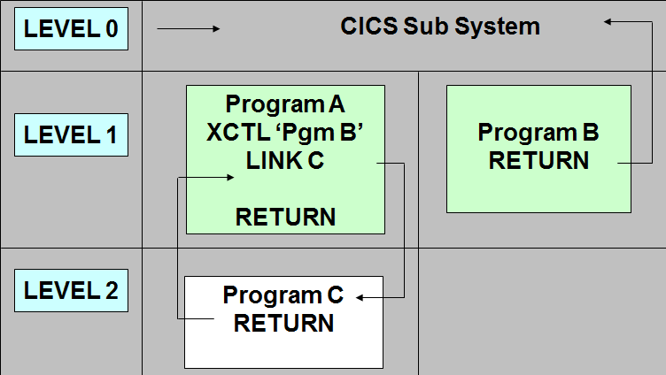

Figure 19: XCTL and LINK Logical Levels

The application programs under CICS run under various logical levels. At the highest level is CICS (Level 0). All application programs run at lower logical levels.
- A LINK’ed program runs at the next lower logical level from the linking program.
- A XCTL’ed program runs at the same logical level as the XCTL’ing program.
- The RETURN command always passes control back to the program at one logical level higher.
The visual explains the flow of control between programs.
- The program A is at the highest logical level under CICS (level 1).
- RETURN from program A cause control return to CICS (level 0).
- When program A issues XCTL to program B, the program B will be at the same logical level (level 1)
- When program A issues a LINK to program C, program C will be at level 2.
- RETURN from program C passes control to level 1 (program A).
- RETURN from program B passes control to level 0 (CICS).

29.1 LINK
When one program LINKs to another, the first program stays in the main storage while the second program is executing.
When the second (LINKed to) program ends and returns control, the first program resumes at the point after the LINK statement. The LINKed to program is considered to be operating at one logical level lower than the LINKing program.
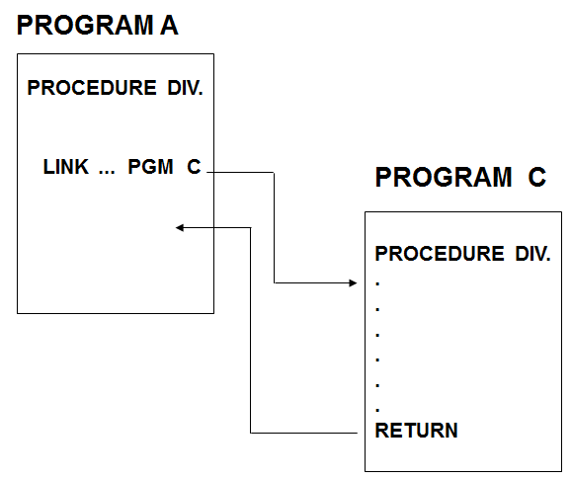

Figure 20: Process of Calling a Link’ed program from Main program – Lower Logical Levels
LINK must be used for programs which need to return to the program that invoked it. All LINKed to programs must have a RETURN command.
29.1.1 Passing Data using LINK
Data from the linking program to the linked to program can be passed using the COMMAREA option.
If the COMMAREA OPTION is used in the LINKing program, the area must be defined in the working storage section. In the LINKed program, the area must be defined as the first area in the linkage section, under the reserved name DFHCOMMAREA.

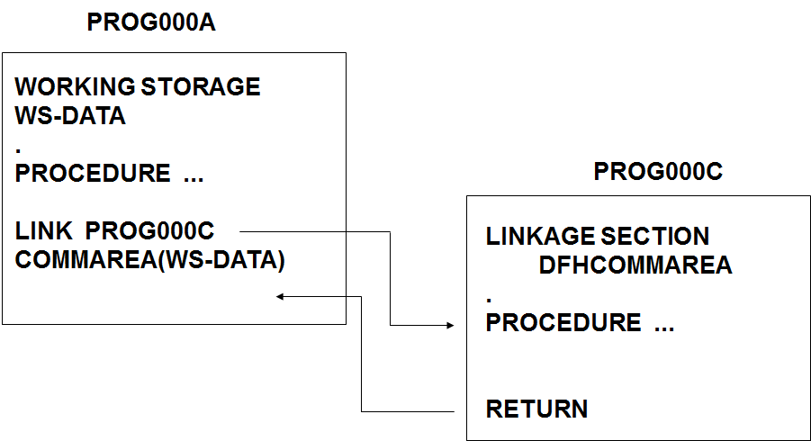

Figure 21: Internal Process of Calling a Link’ed program from Main program

The COMMAREA is shared between the two programs. When the LINKing program regains control, any changes made to the COMMAREA by the LINKed to program are accessible.
The WORKING STORAGE Section of the LINKing program is retained till its execution ends. But the Working storage of the LINKed to program is automatically released after the RETURN command.

Both the linking and the linked programs execute under the same task.

29.1.2 LINK Command
EXEC CICS LINK PROGRAM(pgm-name)
COMMAREA(comm-area)
LENGTH(length)
END-EXEC.
Example:
EXEC CICS LINK PROGRAM(‘PROG000C’)
COMMAREA(WS-DATA)
LENGTH(WS-DATA-LENGTH)
END-EXEC.

PROGRAM Specified the name of the program to which is to be Linked. If the name is a literal, it should be enclosed in quotes. Program name can be unto eight characters long. The program must be defined in the PPT.
COMMAREA Optional parameter, specifying the data area containing the data to be passed to
the LINKed to program. This option is required only if you want to pass information to the program being linked to.
LENGTH Specifies the length of the COMMAREA. This parameter is required only if COMMAREA is present. Like length parameters in other commands, it must be a half word binary.

29.2 XCTL
When one program XCTLs to another, i.e.., transfers control, the first program is considered terminated, and the second program operates at the same level as the first program.

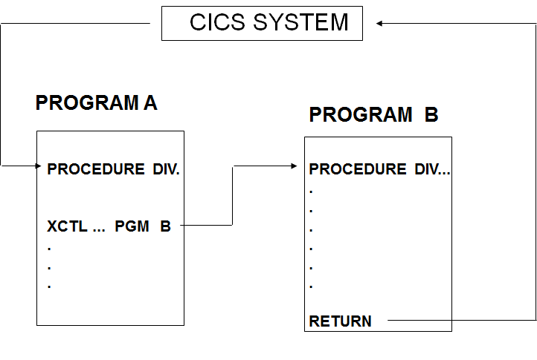

Figure 22: Process of Calling a XCTL’ed program from Main program – Same Logical Level

When the execution of the second program ends the control is returned not to the first program, but to a program which is at a higher logical level or to CICS, if the first program was invoked directly under CICS.

29.2.1 Passing Data using XCTL
Data from the XCTLing program to XCTLed program can be passed using the COMMAREA option.
If the COMMAREA is used in the program which is performing the XCTL, the area must be defined in the working storage section. In the called program the area must be defined as the first area in the LINKAGE SECTION, using the DFHCOMMAREA. Only a copy of the data is passed and not the address.

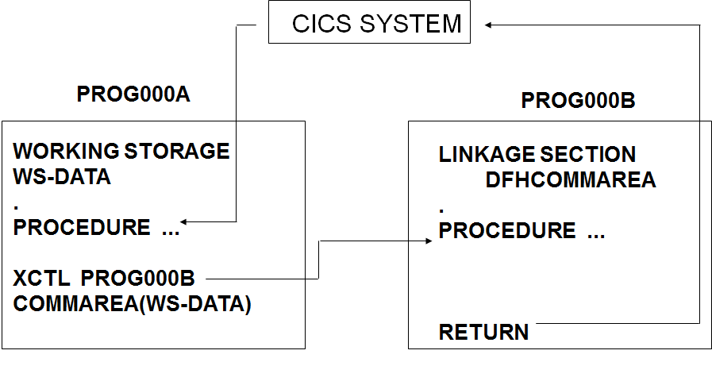
Figure 23: Internal Process of Calling a XCTL’ed program from Main program
Both the XCTLing and the XCTLed programs execute under the same task.

29.2.2 XCTL Command
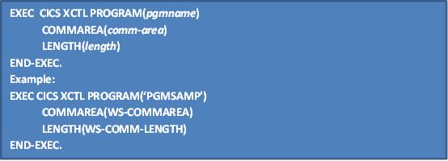

PROGRAM Name of the program to which we wish to transfer control. If the name is a literal, it should be enclosed in quotes. Program name can be eight characters long and should be defined in PPT.
COMMAREA An optional parameter. When specified, it is the name of the area containing the data to be passed. This option is required only if you want to pass information to XCTLed to program.
LENGTH Specifies the length of the commarea. This parameter is required only COMMAREA is present. Like the length parameters in other commands it must be half word binary.

29.2.3 Difference between XCTL and LINK
XCTL | LINK
XCTL does not expect control back | LINK expects control back
Handle conditions in the main program are not available to the called program. Establish new handle conditions | Handle conditions in the calling program are needed again. Hence use PUSH and POP commands to restore them again
XCTL does not expect control back and hence less overhead on system resources like memory etc. | LINK expects control back and hence the overhead is more in this case on memory etc.
Similar to GO TO | Similar to PERFORM, and control will be passed back to the instruction following this

29.3 CALL
The called program must be link edited with the calling program. If many programs are calling the same program, this will result in more memory occupation.
Program can be called in two ways:
- Static Call
- Dynamic Call

29.3.1 Static CALL
A statically called program does not require to be registered in PPT.

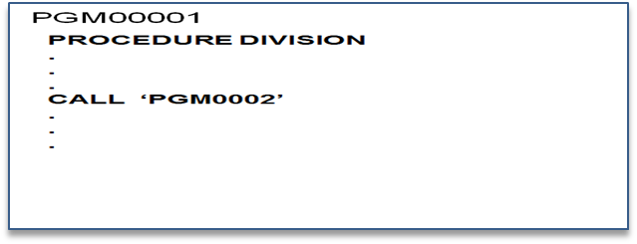

Figure 24: Syntax of a Syntax CALL’ing program calling a CALL’ed program
The Caller and the Called Program must be link-edited together into a single load module.

29.3.2 Dynamic CALL
The dynamic call is available only in VS-COBOL II and CICS 2.1 or later. Dynamically called programs are separate load modules and are therefore shareable by multiple callers. During execution, CICS will dynamically load the called program.
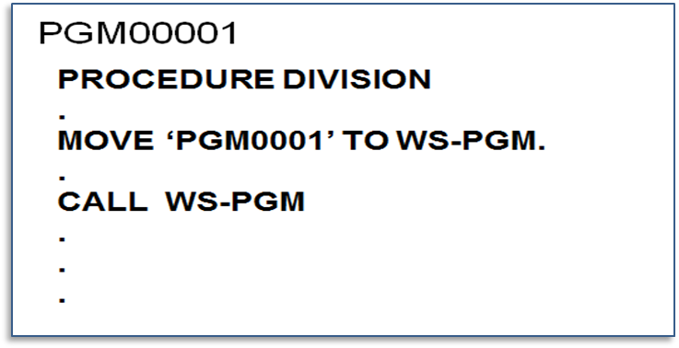
Figure 25: Syntax of a Dynamic CALL’ing program calling a CALL’ed program
The dynamically called program requires to be registered in PPT.

29.3.3 Passing Data in CALL
This is an example of COBOL program using a static call. The format described for passing parameters holds true for dynamic calls as well.
- The first two parameters in the CALL must be DFHEIBLK and DFHCOMMAREA (in that order), and then user defined variables will follow.
- The translator always inserts DFHEIBLK in the LINKAGE SECTION.
- The called program should issue a GOBACK to return to caller.

29.3.4 Difference between CALL and XCTL/LINK

CALL | XCTL/LINK
The CALL’ed program is Link edited along with the main module. | The XCTLed/LINKed program(s) is separately compiled and link edited.
Higher module size and higher memory requirement | Dynamic loading may slow down execution speed
Any changes in the CALL’ed program require compiling of all other modules using the CALL’ed program | Changes in XCTLed/LINKed program(s) will not affect other modules using this

29.4 RETURN
The RETURN command passes control to the next higher level. When the program is at the highest logical level under CICS (level 1), the RETURN command will pass the control back to CICS.
EXEC CICS
RETURN
[TRANSID(next-id)]
[COMMAREA(comm-area)]
[LENGTH(length)]
END-EXEC.
EXEC CICS
RETURN
END-EXEC.

When control is passed back to CICS, two additional options to the RETURN command can be specified:
- Next transaction can be specified to be executed when the next input comes from the same terminal. This option is used to develop applications in pseudo conversational mode which will be discussed shortly.
- Data to be passed to the next transaction can be specified.

TRANSID Specifies the next transaction identifier to be executed from the terminal associated with the current transaction. This is the transaction that is executed the next time that terminal sends input. This can be issued only by transactions at the logical level 1.
COMMAREA An optional parameter. It is the name of the area containing the data to be passed to the next transaction that will be executed at that terminal. LENGTH specifies the length of the COMMAREA.

29.5 LOAD
The LOAD Command is used to load a program or table which is independently compiled or assembled & link-edited and registered in PPT.
This command is useful for loading a table or application program dynamically. That is, as an application, a table can be coded in Assembler, assembled and link-edited. Then COBOL program can load it as a table.

29.5.1 LOAD command - Syntax
EXEC CICS LOAD
PROGRAM (Program Name)
SET (Pointer Reference)
LENGTH (Data Area Length)
LENGTH (Data Area Length)
ENTRY (Pointer Reference)
HOLD
END-EXEC .
Example:
EXEC CICS LOAD
PROGRAM (‘lodprg’)
SET (ptrvar)
LENGTH (lenvar)
END-EXEC .

PROGRAM Program to be loaded into CICS address space
SET Pointer reference to the address of Table/Program/Map
LENGTH S9(4) COMP. Length of module (if length < 32 k)
FLENGTH S9(8) COMP. (if length > 32 k)
HOLD Module resident in memory even when task terminates

29.5.2 LOAD Command Exceptions
- PGMIDERR Program not found
- LENGERR Load module > 32 K
- NOAUTH Security check error

29.6 RELEASE
- Release Command is used to release a program or table which has been loaded previously.
- Name of program must be specified in PROGRAM parameter.

29.6.1 RELEASE Command - Syntax
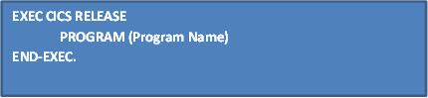
PROGRAM Name of the program to be released.

Sessions 30: Interval Control
The Interval Control Features provided by the CICS interval control program (ICP) are:
- Providing the current date and time in the desired formats (supported by CICS)
- Task initiation at specific time or after an interval.

Different Mechanisms of Handling Interval Control
30.1 ASKTIME
    - To request current date and time.
30.2 FORMATTIME
    - To select format of date and time.
30.3 DELAY
-- To delay the processing of a task.
30.4 START
-- To initiate a transaction from current task.
30.5 RETRIEVE
-- To retrieve data passed by START command.
30.6 CANCEL
    - To cancel the effect of the previous interval control command
30.1 ASKTIME
To request current date and time.
EXEC CICS
ASKTIME[ABSTIME(data_area)]
END-EXEC

ABSTIME Provides the absolute time in milliseconds that has elapsed from from Jan. 1, 1900 onwards in a 15 digit packed decimal field (S9 (15) COMP-3).
FORMATTIME Formats the absolute time as obtained from the ASKTIME command based on the options given.
DATE Specifies an eight byte field where CICS places the date format according to the installation default.
TIME Specifies an eight byte field where CICS places the time in the format hhmmss.
DATESEP Specifies a single character value to be used as a separator character between the day, month and year. If this option is not provided a default value of ‘/’ is used.
TIMESEP Specifies a single character value to be used as a separator character between the Hour, Minute and Seconds. If this option is not provided a default value of ‘:’ is used.

30.2 FORMATTIME
EXEC CICS FORMATTIME
ABSTIME(data-area)
[YYDDD(data-area)]
[YYMMDD(data-area)]
[YYDDMM(data-area)]
[DDMMYY(data-area)]
[MMDDYY(data-area)]
[DATASEP(data-value)]
[DAYOFWEEK(data-area)]
[DAYOFMONTH(data-area)]
[MONTHOFYEAR(data-area)]
[YEAR(data-area)]
[TIME(data-area)
[TIMESEP(data-value)]]
END-EXEC.

30.2.1 FORMATTIME – Example
WORKING STORAGE SECTION.
77 WS-ABS-DATE PIC S9(15) COMP-3
01 WS-DATE.
05 WS-D-MM PIC 99.
05 FILLER PIC X.
05 WS-D-DD PIC 99.
05 FILLER PIC X.
05 WS-D-YY PIC 99.
01 WS-TIME.
05 WS-T-HH PIC 99.
05 FILLER PIC X.
05 WS-T-MM PIC 99.
05 FILLER PIC X.
05 WS-T-SS PIC 99.
PROCEDURE DIVISION.
EXEC CICS ASKTIME
ABSTIME(WS-ABS-DATE)
END-EXEC.
EXEC CICS FORMATTIME
ABSTIME(WS-ABS-DATE)
MMDDYY(WS-DATE)
DATESEP(‘-’)
TIME(WS-TIME)
TIMESEP(:)
END-EXEC.
Result :
WS-DATE : 08-28-97
WS-TIME : 12:23:37

At the completion of this command,
WS-DATE Contain the current date in the form of mm-dd-yy.
WS-TIME Contain the current time in the form of hh:mm:ss.

30.3 DELAY
To delay a task for the specified time interval or until the specific time
The DELAY command is used to delay the processing of a task for the specified time interval or until the specified time. Time or interval is specified in hours, minutes and seconds
In example 1 the task will be suspended for 15 minutes.
In example 2 the task will be suspended until 16:30:00.

30.3.1 DELAY Command -Syntax
EXEC CICS
DELAY INTERVAL(data-value) | TIME (data-value)
END-EXEC
Example 1: Example 2 :
EXEC CICS DELAY EXEC CICS DELAY
INTERVAL(001500) TIME(163000)
END-EXEC. END-EXEC.

30.4 START
The START command is used to start a transaction at the specified terminal and at the specified time or interval. Optionally data can be passed to the to-be-initiated transaction.
START Command –Syntax
EXEC CICS START
TRANSID(data-value)
[TIME(hhmmss) | INTERVAL (hhmmss)]
[AFTER [HOURS(hh)] [MINUTES(mm)] [SECONDS(ss)] |
AT [HOURS(hh)] [MINUTES(mm)] [SECONDS(ss)]]
[TERMID(data-value)]
[FROM(data-area)]
[LENGTH(data-value)]
[REQID(NAME)]
END-EXEC

30.4.1 Scheduled Transaction Initiation ( STI )
STI is an application of START command, by which CICS transactions can be
automatically initiated at scheduled intervals.

Start Command - Example
EXEC CICS START
TRANSID(‘REP1’)
TERMID(‘PRT1’)
TIME(083000)
END-EXEC

TRANSID Defines the Transaction ID of a transaction which is to be initiated
TERMID Defines the Terminal ID f a terminal against which the transaction is initiated. If TERMID is omitted, the specified transaction will be initiated against the terminal with which the current transaction is associated
TIME/INTERVAL Indicates the time or the time interval of the Transaction Initiation, respectively in the form of hhmmss
REQID Specifies an 8 byte value that identifies this START command so that the started task can be cancelled with a CANCEL command. If omitted, CICS still generates the REQID and the same is available in the EIB variable EIBREQID.
The above Transaction ‘REP1’ will be started on terminal (or printer) ‘PRT1’ at 8:30 (if TIME is specified) or 15 minutes later (if INTERVAL is specified).
Data can be passed to the transaction by specifying the FROM and LENGTH options. The FROM option specifies the data area which contains the data to be passed. The length of the data-area should be specified in the LENGTH option. Interval Control stores the data passed in a TSQ for a later RETRIEVE (retrieval).

30.5 RETRIEVE
- To retrieve data passed by a task issuing a START transaction
- The RETRIEVE command is used to retrieve the data passed by the START command which was issued in the transaction which initiated the current transaction.
- In the example, after execution of the command, the WS-DATA will contain the data passed by the START command.

30.5.1 Retrieve Command -Syntax
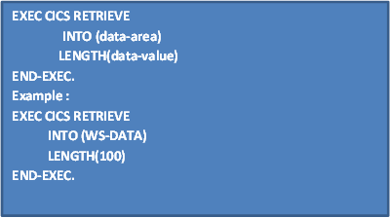
30.5.2 START & RETRIEVE: Example
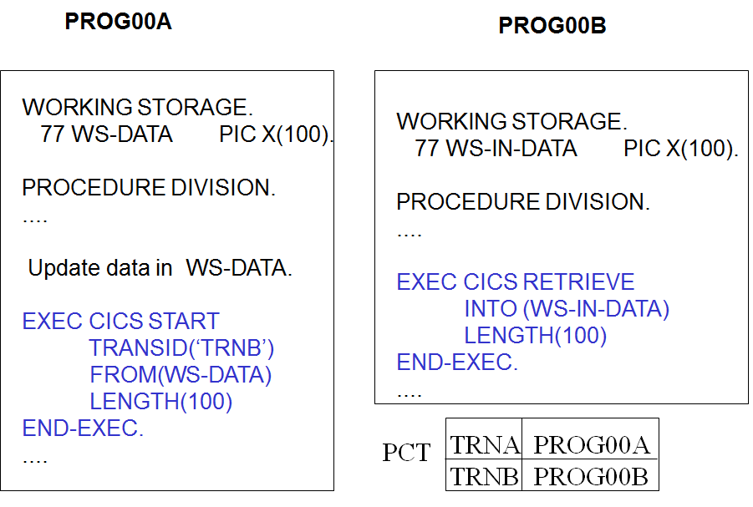
Figure 26: Syntax of START and RETRIEVE usage in CICS program
At the completion of START command in ‘TRNA’, the new transaction TRNB will be initiated.
At the completion of the RETRIEVE command in PROG00B (TRNB), field WS-IN-DATA will contain the data passed from PROG00A (TRNA).

30.6 CANCEL
-- To Cancel a previously issued START command
-- Transaction to be cancelled identified by REQID
*Note: Cannot be cancelled if the transaction had already started.
Syntax
EXEC CICS CANCEL
REQID(data-value)
END-EXEC

Example :
EXEC CICS START
TRNSID(‘TRNA’)
REQID(‘STARTA’)
TIME (050000)
END-EXEC.
....
EXEC CICS CANCEL
REQID(‘STARTA’)
END-EXEC

The CANCEL command is used to cancel the Interval Control commands, such as DELAY or START, which have been issued earlier. The Interval Control commands are identified by the REQID parameter of these commands.
In the example shown above, at the completion of the CANCEL command, the START command identified by ‘STARTA’ will be cancelled.
Sessions 31: Task Control Commands

31.1 SUSPEND Command
- Task suspended and control given to other tasks with higher priority
- Control returns back to the suspended task once other tasks are executed
- Similar to the DELAY Command
EXEC CICS
SUSPEND
END-EXEC.

The SUSPEND command is used to suspend a task. After execution of this command the task will be suspended, and control will be given to other tasks having higher priority. As soon as the all high priority tasks have been executed, control will be returned to the suspended task.
If CPU intensive processing is performed in a program, it is a good practice to issue this command time to time in the program in order to allow other tasks to proceed.

31.2 ENQ and DEQ Commands
-- The ENQ command is used to gain exclusive control over a resource.
-- The DEQ command is used to free the exclusive control over a resource.
-- CICS automatically provides exclusive control over resources to a task in most cases. CICS application systems can be developed in such a way that an application program does not have to issue the ENQ, DEQ commands.

31.2.1 ENQ Command
To gain exclusive control over a resource
ENQ Command - Syntax
EXEC CICS ENQ
RESOURCE(resource-id)
END-EXEC.

31.2.2 DEQ Command
To free the exclusive control from a resource
EXEC CICS DEQ
RESOURCE(resource-id)
END-EXEC.

31.2.3 ENQ & DEQ for TSQ Access: Example
Application that requires two or more tasks that access a common TS queue

EXEC CICS ENQ
RESOURCE (TSQ-QID)
END-EXEC.
EXEC CICS READQ
QUEUE (TSQ-QID)
RESP(WS-RESP)
END-EXEC.
:
(Update the contents of TSQ)
:
EXEC CICS WRITEQ
QUEUE (TSQ-QID)
REWRITE
END-EXEC.
EXEC CICS DEQ
RESOURCE (TSQ-QID)
END-EXEC.

Sessions 32: Storage Control

- Used to provide temporary work areas for the task that is normally not provided by CICS
- Since more applications are using storage areas provided and managed by CICS, the use of GETMAIN and FREEMAIN will continue to diminish in COBOL programs

32.1 GETMAIN
- To get main memor
32.2 FREEMAIN
- To release the memory acquired by GETMAIN

